EARTH ANGEL VENTURES
Ripple Effect Theory: A Framework for Propagating Change Across Time and Interconnected Systems
Original Theoretical Research Manuscript | Project EAV-RET-001 | Version 1.0

1. DOCUMENT CONTROL AND FRONT MATTER

1.1 Document control
Table 1. Document control record
Field | Entry
Full Title | Ripple Effect Theory: A Framework for Propagating Change Across Time and Interconnected Systems
Short Title | Ripple Effect Theory (RET)
Classification | Original theoretical proposal with a complete, pre-specified experimental programme (hypothesis and protocol; no empirical data collected)
Research Program | Earth Angel Ventures Theoretical Science Program: Propagation, Causality, and Interconnected Systems
Project ID | EAV-RET-001
Manuscript ID | EAV-RET-001-M01
Status | Complete manuscript for internal review; ready for registration of the protocol before any data collection
Date | 24 October 2026
Primary Discipline | Complex systems science (dynamical systems and network science)
Secondary Disciplines | Causal inference and statistics; applied physics (wave propagation, electrical networks); systems engineering (cascading failure)
Lead Author | Angelica Pangan
Research Owner | Earth Angel Ventures, Philippines
Version | 1.0 (supersedes working draft EAV-TH-002)

1.2 Author and affiliation
Author: Angelica Pangan. Affiliation: Earth Angel Ventures, Philippines.

Manuscript conventions. Every symbol is defined in Table 5 and every equation is collected in the Formula Basis Chart (Section 6). Vectors and matrices are written in bold in equation images; in running text a capital letter such as A denotes a matrix. Quantities are expressed in SI units. The bracket [x] denotes the unit of the measured state variable of whichever system is studied (volt, metre, or a dimensionless count). All figures that show model output are labelled as model-computed illustrations; they are not data.

1.3 Contents of this manuscript
Table 2. Sections of this manuscript
Section | Title
1 | Document Control and Front Matter
2 | Abstract
3 | Research Significance
4 | Highlights
5 | Visual Emblem
6 | Formula Basis Chart
7 | Symbol and Sign Chart
8 | Visual Blueprints
9 | Introduction, Scope, and Hypotheses
10 | Formal Model: Primary Postulates
11 | Extended Mechanisms
12 | Experimental Programme and Falsification
13 | Comparison With Existing Frameworks and Novelty Protocol
14 | Results
15 | Discussion, Limitations, and Planned Versions
16 | Conclusion
17 | Ethics, Transparency, and Integrity
18 | References
19 | Final Declaration

1.4 List of figures and tables
Table 3. List of figures
Figure | Title | Section
Figure 1 | Ripple Effect Theory emblem. | 5
Figure 2 | Formula Basis Chart, Panel A (Equations 1 to 9). | 6
Figure 3 | Formula Basis Chart, Panel B (Equations 10 to 18). | 6
Figure 4 | Formula Basis Chart, Panel C (Equations 19 to 25). | 6
Figure 5 | Core structure of a propagating disturbance. | 8
Figure 6 | Hop-propagation operator. | 8
Figure 7 | Interaction diagram for one coupling and one component. | 8
Figure 8 | Hop dose against hop number for four values of the Ripple Number. | 8
Figure 9 | Ripple field along a feed-forward chain of five components. | 8
Figure 10 | Directed ring of four components and the pulse recurrence it produces. | 8
Figure 11 | Threshold activation rule and cascade size against mean degree. | 8
Figure 12 | Amplitude against distance for media of dimension 1, 2, and 3. | 8
Figure 13 | Decision flow of the Ripple Attribution Criterion. | 8
Figure 14 | Architecture of the electronic coupled-node apparatus (Experiments E2 and E5). | 8
Figure 15 | Layout of the radial tank and the channel (Experiment E3). | 8
Figure 16 | Timing of one trial and the order of trials within a block. | 8
Figure 17 | Acceptance region of the cross-domain parity law. | 8

Table 4. List of tables
Table | Title | Section
Table 1 | Document control record | 1
Table 2 | Sections of this manuscript | 1
Table 3 | List of figures | 1
Table 4 | List of tables | 1
Table 5 | Symbols and signs used in the formulas | 7
Table 6 | Defined terms | 7
Table 7 | Separation of established results from RET hypotheses | 9
Table 8 | Related approaches and their limits relative to RET | 9
Table 9 | Admissibility conditions | 9
Table 10 | Hypotheses | 9
Table 11 | Criteria of the Ripple Attribution Criterion | 10
Table 12 | Worked example of Postulates 2 and 3 | 10
Table 13 | Rules that apply to all experiments | 12
Table 14 | Experiment E1: Computational verification | 12
Table 15 | Experiment E2: Electronic coupled-node network | 12
Table 16 | Experiment E3: Fluid surface-wave tank | 12
Table 17 | Experiment E4: Cross-domain parity test | 12
Table 18 | Experiment E5: Attribution and common-cause test | 12
Table 19 | Summary of hypotheses, metrics, and decision thresholds | 12
Table 20 | Order of execution | 12
Table 21 | Comparison of RET with standard frameworks | 13
Table 22 | Literature search protocol for the novelty claim | 13
Table 23 | Results by experiment | 14
Table 24 | Decision matrix for the experimental outcomes | 15
Table 25 | Limitations and handling | 15
Table 26 | Applicability of version 1.0 by domain | 15
Table 27 | Planned versions and their conditions | 15
Table 28 | Ethics, transparency, and integrity statements | 17
Table 29 | Reference list | 18

2. ABSTRACT
Background. A change in one component of an interconnected system often alters other components later in time and elsewhere in space. This phenomenon is studied under separate names: causal inference, nonlinear dynamics, network cascades, and wave propagation. No single operational test currently states when a downstream change is a genuine propagated consequence of an initiating event, as opposed to a coincidence or the result of a shared cause.

Objective. To formalise Ripple Effect Theory (RET) as a bounded and falsifiable framework that predicts the magnitude, timing, recurrence, and persistence of downstream effects from independently measured couplings, and that states exactly when a downstream change may and may not be attributed to an initiating event.

Methods. RET defines the ripple field as the counterfactual difference between a disturbed system and its baseline (Eq. (3)). It states eight postulates built on a linear delayed network response, the Ripple Number Ω (the spectral radius of the hop-gain matrix), a causality bound on arrival time, a loop-recurrence law, a threshold-cascade criterion, a five-part Ripple Attribution Criterion, and a cross-domain parity law. Five experiments with fixed sample sizes and numerical decision thresholds are specified: a computational verification, a 16-node electronic network, a fluid surface-wave tank, a cross-domain parity analysis over three systems, and a 400-block attribution test.

Results. No empirical data have been collected and no experimental result is claimed. The results reported here are analytic and are derived from the stated equations: hop doses scale as A^{k}, the asymptotic attenuation rate is λ = −ln Ω, a feedback loop returns a pulse after T_{rec} with area ratio R_{rec}, and no ripple can arrive earlier than the minimum-delay path distance. Curves shown in the figures are computed from the model equations and are labelled as illustrations.

Interpretation. Ω is established mathematics (the spectral radius criterion of linear stability, input-output analysis, and branching processes). RET does not claim Ω as a new law. Its contribution is the combination of counterfactual measurement, independently measured couplings, a causality bound, and a pre-registered cross-domain test. If the thresholds are met, RET supplies a shared quantitative vocabulary for propagation in the tested domains. If they are not met, each threshold identifies which postulate fails and the scope of the theory is reduced accordingly.

Conclusion. RET is presented as a complete, testable framework with defined scope, defined measurements, and defined failure conditions. The theory does not claim that every later event is caused by an earlier one.

Keywords: ripple effect, causality, propagation, feedback systems, dynamical systems, networks, temporal processes, cascading failure, spectral radius, falsifiability.

3. RESEARCH SIGNIFICANCE
Scientific significance. The framework converts the informal idea of a ripple effect into measurable quantities: the ripple field Δ_{i}(t), the integrated dose M_{i}, the Ripple Number Ω, the arrival time T_{i}, and the recurrence ratio R_{rec}. It supplies a causality bound and an attribution rule that separate propagation from coincidence, which prevents the theory from describing any sequence of events retrospectively as a ripple.

Methodological significance. All predictions are computed from independently measured couplings before any ripple data are recorded, so the models carry zero fitted parameters in the primary tests. Decisions use equivalence bounds with stated sample sizes. This design allows the theory to fail clearly.

Practical significance. In the three domains tested (electronic networks, surface waves, and cascading failure in power grids) the framework offers a common way to estimate how far and how long a disturbance persists, and whether a feedback loop will amplify or damp it. The same quantities can support design choices such as setting a coupling gain so that Ω stays below 1.

Limits of the claim. The theory is restricted to systems that meet the admissibility conditions in Section 9.6. Social, historical, and other systems whose couplings cannot be measured independently are outside the scope of version 1.0.

4. HIGHLIGHTS
- A ripple is defined as a counterfactual difference between a disturbed system and its baseline, which makes it measurable (Eq. (3)).
- The total integrated effect of a disturbance is M = (I − A)⁻¹ M⁽⁰⁾. When Ω < 1 the hop doses decay as Ω^{k} with attenuation length ℓ = −1/ln Ω (Eq. (7), Eq. (9)).
- No component can show a ripple earlier than its minimum-delay path distance d_{τ}(s,i). A violation identifies a hidden path or a common cause (Eq. (12)).
- A feedback loop returns a pulse after T_{rec} with area ratio R_{rec}, which fixes the number of detectable recurrences and the persistence time (Eq. (13), Eq. (14)).
- A five-criterion Ripple Attribution Criterion converts "B followed A" into a testable attribution, with sensitivity and specificity lower bounds of 0.90 required (Eq. (17)).
- The unifying claim is a cross-domain parity law with slope ψ = 1 within ±0.15 for three different systems (Eq. (23)). Failure in a domain removes that domain from the scope of the theory.
- Scope conditions, sample sizes, thresholds, and stopping rules are fixed before data collection. No empirical data are claimed.

5. VISUAL EMBLEM
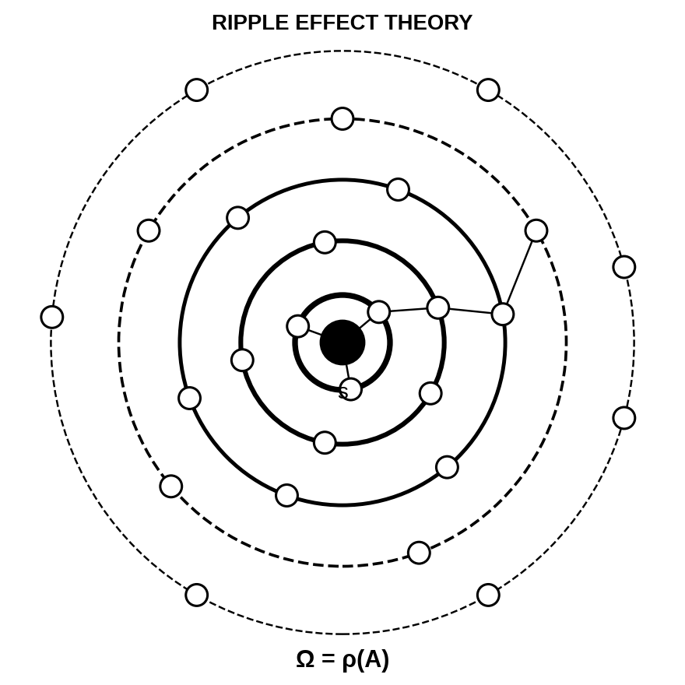
Figure 1. Ripple Effect Theory emblem. The central filled circle is the disturbed source component s. Each ring is one hop of propagation; ring line weight decreases to represent attenuation, and the dashed outer rings represent hops whose doses fall toward the detection limit. Small circles are components and the short lines are couplings. The expression Ω = ρ(A) at the base is the Ripple Number that governs whether the rings shrink or grow.

6. FORMULA BASIS CHART
This chart collects every equation of the manuscript in one place, numbered in the order in which the equations are used. Each symbol is defined in Table 5. Equations 1 to 3 define the model and the measured quantity. Equations 4 to 18 state Postulates 1 to 7 together with the detection thresholds. Equations 19 to 22 give the extended mechanisms. Equations 23 to 25 give the parity law of Postulate 8 and the statistical decision rules.

Figure 2. Formula Basis Chart, Panel A (Equations 1 to 9). Model definition, linear delayed response, integrated dose, and attenuation.


Figure 3. Formula Basis Chart, Panel B (Equations 10 to 18). Amplification, delay and causality bound, loop recurrence, persistence, threshold cascade, attribution, and detection thresholds.

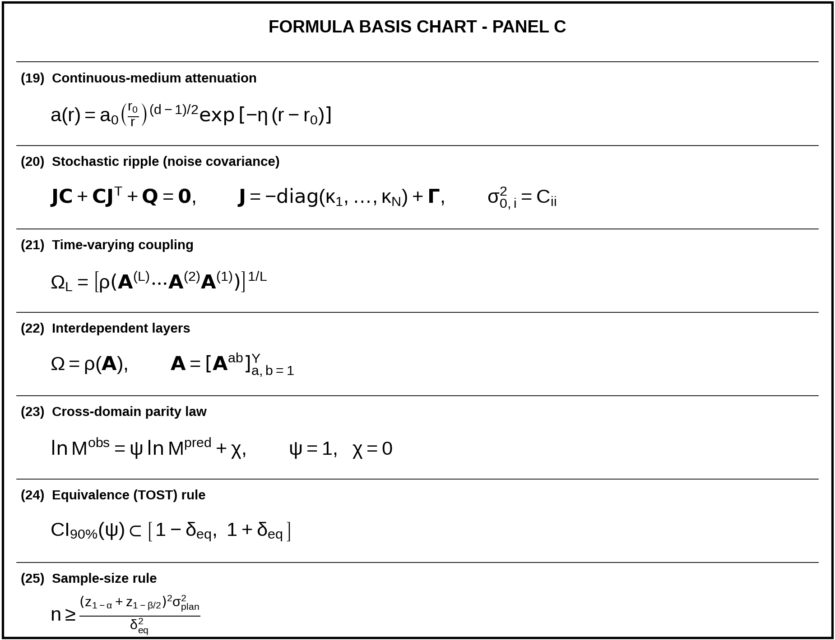
Figure 4. Formula Basis Chart, Panel C (Equations 19 to 25). Continuous-medium attenuation; stochastic, time-varying, and layered extensions; parity law; equivalence rule; and sample-size rule.

7. SYMBOL AND SIGN CHART
Table 5 defines every symbol and sign used in the equations and text. The unit [x] is the unit of the measured state variable: volt in the electronic network, metre in the wave tank, and a dimensionless count in cascade models. "1" means dimensionless.
Table 5. Symbols and signs used in the formulas
Symbol | Definition | Unit
Indices and counts
i, j | Component indices: i is the receiving component and j is the sending component | 1
s | Index of the source (disturbed) component | 1
N | Number of components in the bounded system | count
k | Hop number: the count of couplings an effect has traversed | count
m | Index of an attribution criterion, 1 to 5 | 1
v | Sample offset in the consecutive-sample rule, v = 0 to m_{c} − 1 | count
L | Number of time-ordered coupling snapshots; l indexes the snapshot | count
Y | Number of interdependent layers; a, b index layers | count
n | Number of independent trials per experimental condition | count
State variables and perturbation
x_{i}(t) | State of component i at time t | [x]
x, x₀ | State vector of the system and its baseline value | [x]
x_{i}^{base}(t), x_{i}^{dist}(t) | State of component i in the baseline run and in the disturbed run | [x]
t | Time | s
ε | Magnitude of the initial perturbation (impulse size) | [x]
e_{s} | Unit vector with value 1 at source s and 0 elsewhere | 1
u_{i}(t) | External input to component i | [x]/s
Δ_{i}(t) | Ripple field: counterfactual difference at component i, x^{dist} − x^{base} | [x]
Network structure
f_{i} | Intrinsic dynamics of component i | [x]/s
g_{ij} | Coupling function: influence of component j on component i | [x]/s
W_{ij} | Coupling weight from j to i | 1
τ_{ij} | Transport delay from j to i | s
κ_{i} | Relaxation rate of component i, κ_{i} = −∂f_{i}/∂x_{i} at baseline (positive) | 1/s
Γ_{ij} | Linearised coupling strength, Γ_{ij} = W_{ij} ∂g_{ij}/∂x_{j} at baseline | 1/s
Γ | Matrix of the Γ_{ij} | 1/s
A_{ij} | Hop gain from j to i, A_{ij} = Γ_{ij}/κ_{i} | 1
A, |A| | Hop-gain matrix and the matrix of its absolute values | 1
A^{(l)} | Hop-gain matrix of the l-th coupling snapshot | 1
A^{ab} | Block of A that couples layer b to layer a | 1
I, 1 | Identity matrix and vector of ones | 1
T (superscript) | Matrix transpose | none
diag(·) | Diagonal matrix built from the listed entries | none
c_{g} | Gain-scale factor that multiplies every A_{ij} | 1
Ripple measures
M_{i} | Integrated ripple dose of component i, the time integral of Δ_{i} | [x]·s
M, M⁽⁰⁾ | Dose vector and source dose vector, M⁽⁰⁾ = (ε/κ_{s}) e_{s} | [x]·s
M^{(k)} | Dose vector contributed by effects that traversed exactly k couplings | [x]·s
M_{k} | Total hop-k dose, the sum of M_{i}^{(k)} over i | [x]·s
M_{fp} | First-pass dose of a pulse around a loop | [x]·s
M^{obs}, M^{pred} | Observed dose and frozen model-predicted dose | [x]·s
K₀ | Prefactor of the asymptotic hop-dose decay | [x]·s
R_{is} | Reachability index from source s to component i | 1
Ω | Ripple Number, Ω = ρ(A) | 1
Ω₀ | Ripple Number at c_{g} = 1; critical gain scale is c_{g}* = 1/Ω₀ | 1
ρ(·) | Spectral radius: largest absolute eigenvalue of a matrix | 1
λ | Attenuation rate per hop, λ = −ln Ω | 1 per hop
ℓ | Attenuation length, ℓ = 1/λ | hops
G_{s} | Ripple amplification factor for source s | 1
Timing, loops, and persistence
d_{τ}(s,i) | Minimum-delay path distance from s to i | s
Ξ(s→i) | Set of directed paths from s to i; π is one path | none
T_{i} | Arrival time of the ripple at component i | s
θ | Amplitude detection threshold, θ = 3σ₀ | [x]
θ_{M} | Dose detection threshold, θ_{M} = 3σ_{M} | [x]·s
σ₀ | Standard deviation of baseline noise of Δ_{i} | [x]
σ_{M} | Standard deviation of the baseline dose integral | [x]·s
h | Sampling period of the data acquisition | s
m_{c} | Consecutive samples that must exceed θ (fixed at 5) | count
Λ | A directed simple loop of couplings | none
T_{rec} | Loop recurrence period | s
R_{rec} | Loop recurrence ratio (dose ratio between successive passes) | 1
P | Persistence time: time during which recurrences remain above θ_{M} | s
Threshold cascade
y_{i}(t) | Activation state of component i (0 inactive, 1 active) | 1
H(·) | Heaviside step: 1 if the argument is zero or positive, otherwise 0 | 1
φ_{i} | Activation threshold of i, as a fraction of its total incoming weight | 1
B^{NB} | Non-backtracking matrix on the directed edges that can trigger a vulnerable component | 1
Ω_{φ} | Threshold-cascade Ripple Number, Ω_{φ} = ρ(B^{NB}) | 1
S | Cascade size: fraction of components active at the end | 1
ν | Mean degree (average number of links per component) | 1
b, p_{b} | Degree b of a component and the fraction of components with degree b | 1
Continuous media
a(r) | Wave amplitude at distance r from the source | [x]
a₀ | Amplitude at the reference distance r₀ | [x]
r, r₀ | Distance from the source and reference distance | m
d | Spatial dimension of the medium (1, 2, or 3) | 1
η | Spatial damping coefficient | 1/m
Stochastic extension
J | Jacobian matrix, J = −diag(κ₁,…,κ_{N}) + Γ | 1/s
C | Stationary covariance matrix of the ripple field | [x]²
Q | Noise intensity matrix | [x]²/s
Ω_{L} | Ripple Number of L time-ordered snapshots | 1
Attribution and statistics
RAC_{i} | Ripple Attribution Criterion for component i (1 accept, 0 reject) | 1
q_{m,i} | Indicator (0 or 1) that criterion m is met at component i | 1
R_{S} | Spearman rank correlation | 1
Se, Sp | Sensitivity and specificity of the attribution criterion | 1
ψ, χ | Slope and offset of the parity law, ln M^{obs} = ψ ln M^{pred} + χ | 1
δ_{eq} | Half-width of the equivalence region around the predicted value | as quantity
CI_{90%} | Two-sided 90% confidence interval | as quantity
α, β | Type I error (0.05) and type II error (0.10) | 1
z_{p} | Standard normal quantile at probability p | 1
σ_{plan} | Planning standard deviation of the per-trial estimate of ψ (0.25) | 1

7.1 Defined terms
Table 6. Defined terms
Term | Definition
Ripple | A downstream change that satisfies all five criteria of the Ripple Attribution Criterion (Eq. (17)).
Ripple field | The difference Δ_{i}(t) between the disturbed system and its baseline at component i (Eq. (3)).
Dose | The time integral M_{i} of the ripple field at component i. Dose is conserved through first-order relaxation, which makes it the preferred magnitude measure.
Hop | One coupling traversed by an effect. An effect has hop number k after traversing k couplings.
Ripple Number | Ω = ρ(A), the spectral radius of the hop-gain matrix. It decides whether hop doses shrink (Ω < 1), persist (Ω = 1), or grow (Ω > 1).
Baseline | The behaviour of the same system without the perturbation, measured by sham trials or estimated by a stated model.
Sham trial | A trial with the same trigger, timing, and recording as a perturbation trial but with the perturbation source disconnected.
Common cause | An influence that acts on several components without passing through the couplings from the source.
Frozen prediction | A model prediction written to a time-stamped file and hashed before any ripple data are recorded.
Equivalence region | An interval around a predicted value inside which the 90% confidence interval of an estimate must lie for the prediction to be supported.
Admissible system | A system that meets conditions A1 to A5 of Section 9.6.

8. VISUAL BLUEPRINTS
Each model, mechanism, and apparatus used in this manuscript has one diagram below. Graphs are produced by solving the stated equations numerically; they are illustrations of the model and are not empirical results.

8.1 Core network structure
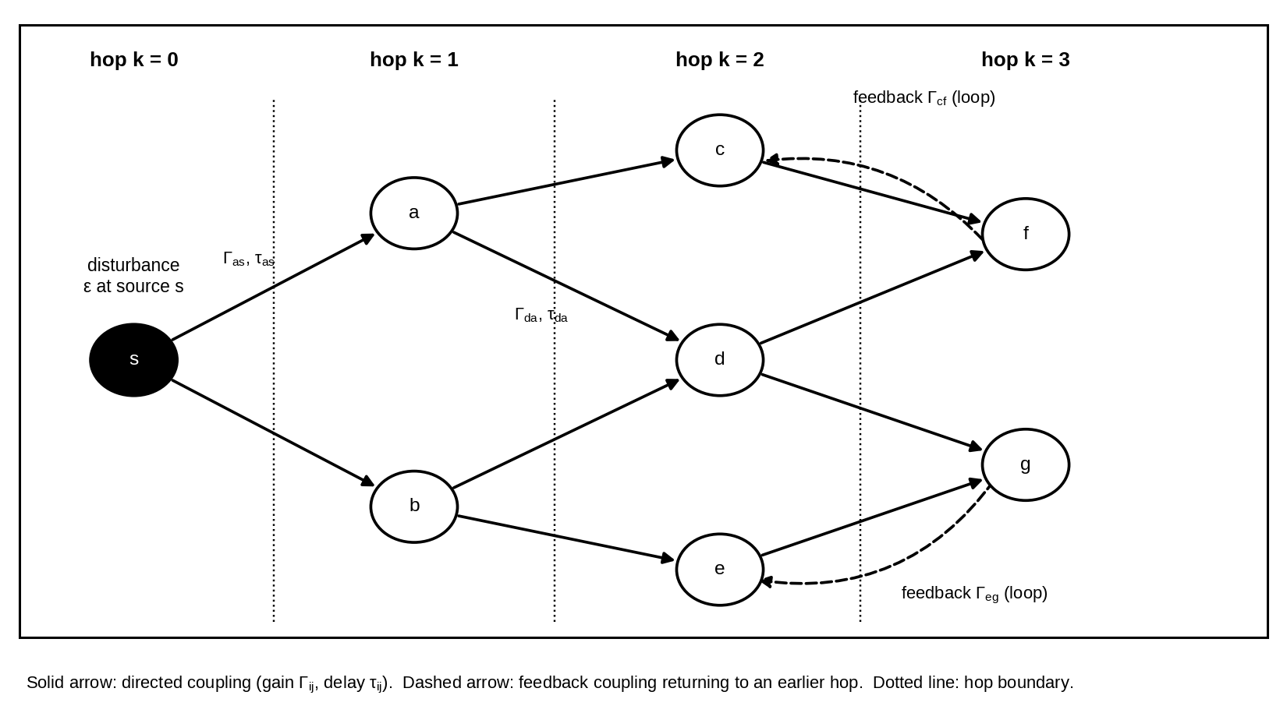
Figure 5. Core structure of a propagating disturbance. A disturbance ε is applied at source s. Solid arrows are directed couplings with gain Γ_{ij} and delay τ_{ij}. Components are arranged by hop number. Dashed arrows are feedback couplings that return an effect to an earlier hop and create loops (Postulate 5).

8.2 Hop-propagation operator
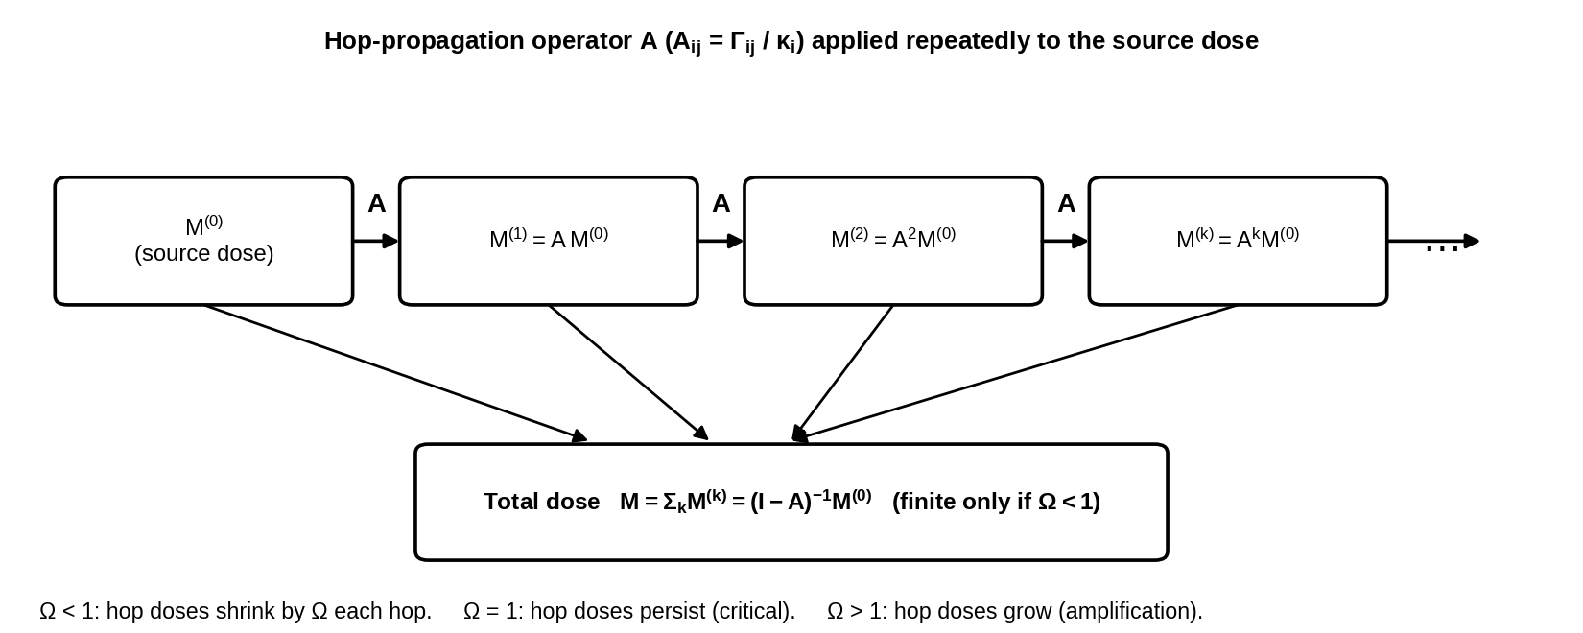
Figure 6. Hop-propagation operator. The source dose M⁽⁰⁾ is multiplied by the hop-gain matrix A once per hop. The total dose is the sum of all hop doses and is finite only when Ω < 1 (Eq. (8)).

8.3 Coupling, relaxation, and threshold gate
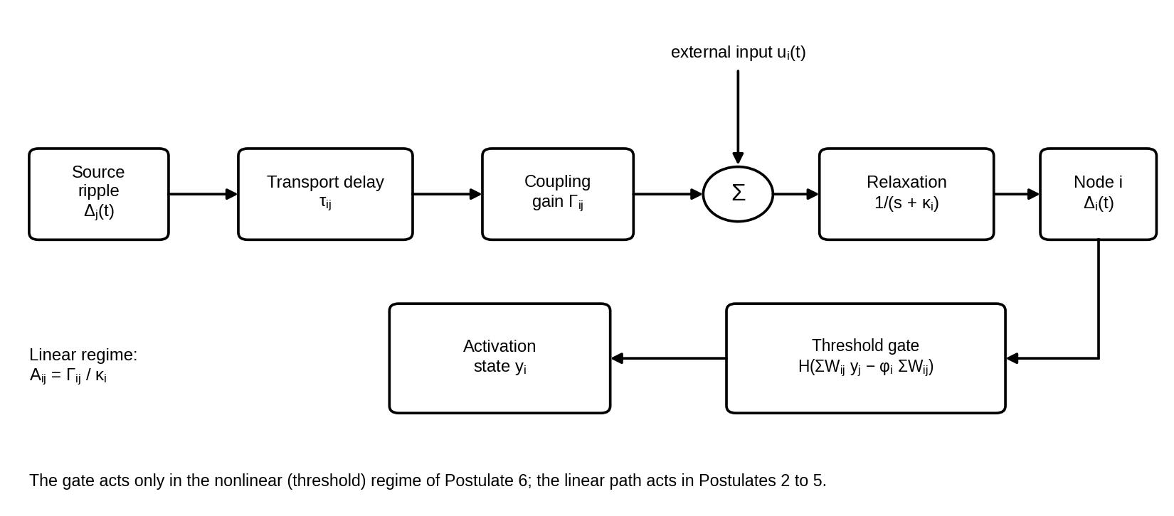
Figure 7. Interaction diagram for one coupling and one component. The signal from component j is delayed by τ_{ij}, multiplied by Γ_{ij}, added to any external input, and relaxed at rate κ_{i}. In the nonlinear regime a threshold gate with level φ_{i} converts the incoming activity into the activation state y_{i}.

8.4 Attenuation regimes
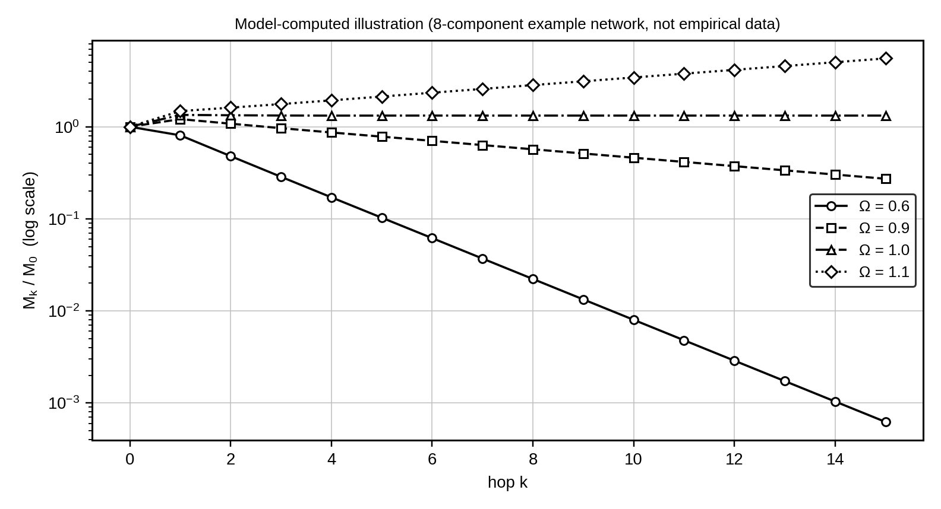
Figure 8. Hop dose against hop number for four values of the Ripple Number. Doses are normalised by the source dose. For Ω < 1 the dose falls on a straight line in a logarithmic plot with slope ln Ω. At Ω = 1 the dose persists, and at Ω > 1 it grows. The curves are computed from Eq. (8) for an 8-component example network.

8.5 Delay, arrival, and the causality bound
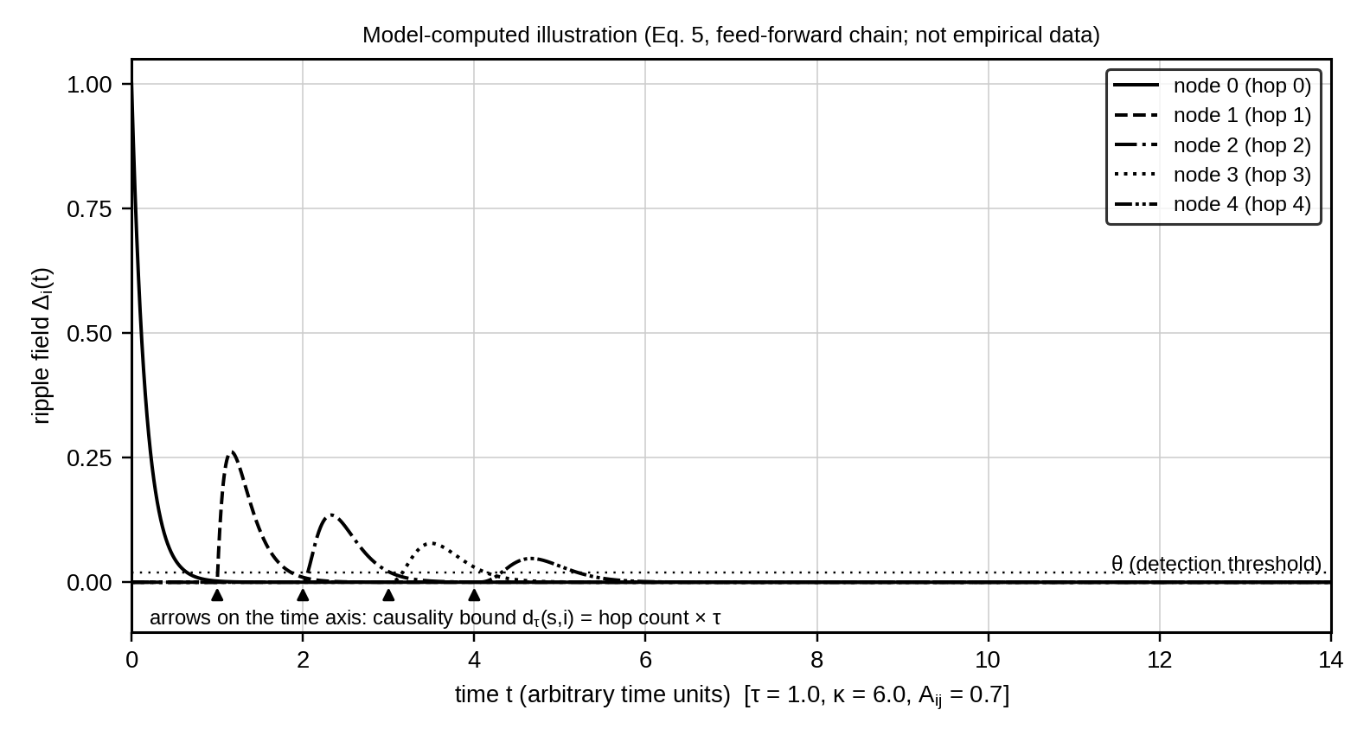
Figure 9. Ripple field along a feed-forward chain of five components. Each hop adds a transport delay τ = 1.0 and multiplies the dose by 0.7. The arrows on the time axis mark the causality bound d_{τ}(s,i) from Eq. (11). No curve may rise above the detection threshold θ before its arrow. The computed doses of nodes 0 to 4 equal 1.00, 0.70, 0.49, 0.34, and 0.24 times the source dose, which matches A^{k}.

8.6 Feedback loop and recurrence
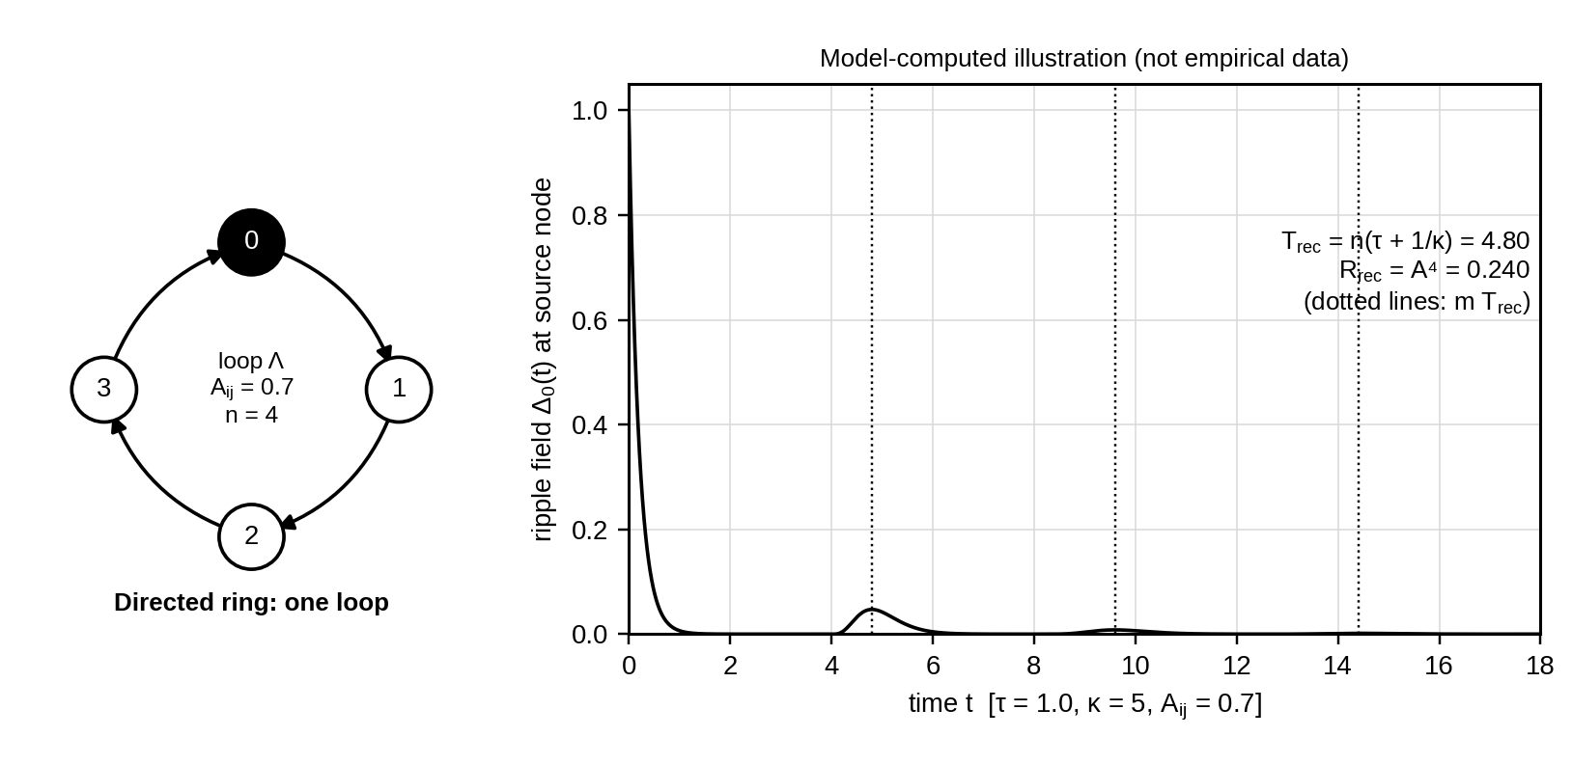
Figure 10. Directed ring of four components and the pulse recurrence it produces. A pulse leaves the source and returns after T_{rec} = 4.80 with a dose ratio R_{rec} = 0.7⁴ = 0.240 per pass. The computed pass-to-pass dose ratios are 0.2400, 0.2401, and 0.2410, which agree with R_{rec} (Eq. (13)).

8.7 Threshold cascade
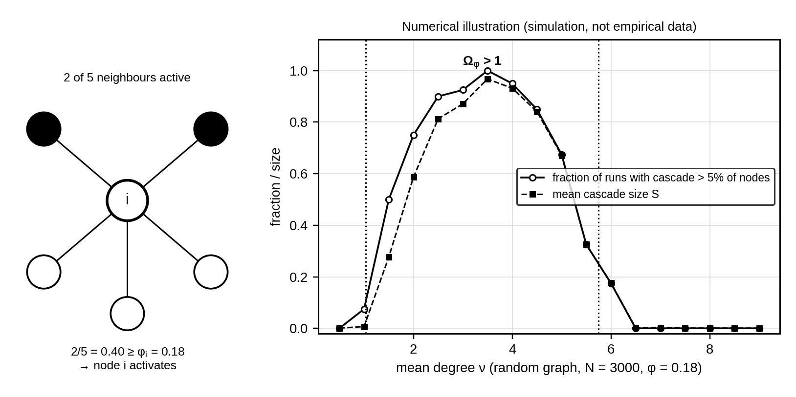
Figure 11. Threshold activation rule and cascade size against mean degree. Left: a component activates when the active fraction of its neighbours reaches φ_{i}. Right: simulated cascade frequency and mean size on random graphs with φ = 0.18. The dotted lines mark the interval 1.04 < ν < 5.74 where the criterion Ω_{φ} > 1 of Eq. (16) holds.

8.8 Attenuation in continuous media
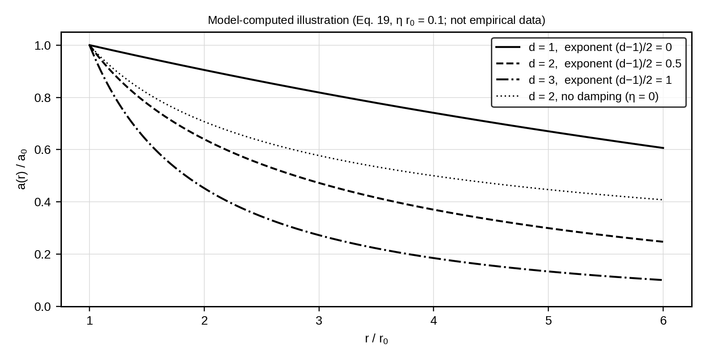
Figure 12. Amplitude against distance for media of dimension 1, 2, and 3. Geometric spreading adds the factor (r₀/r)^{(d−1)/2} to the exponential damping of Eq. (19). For d = 1 only damping remains, which is the form A₀e^{−λr} of the original working draft. The curves are computed with ηr₀ = 0.1.

8.9 Ripple Attribution Criterion
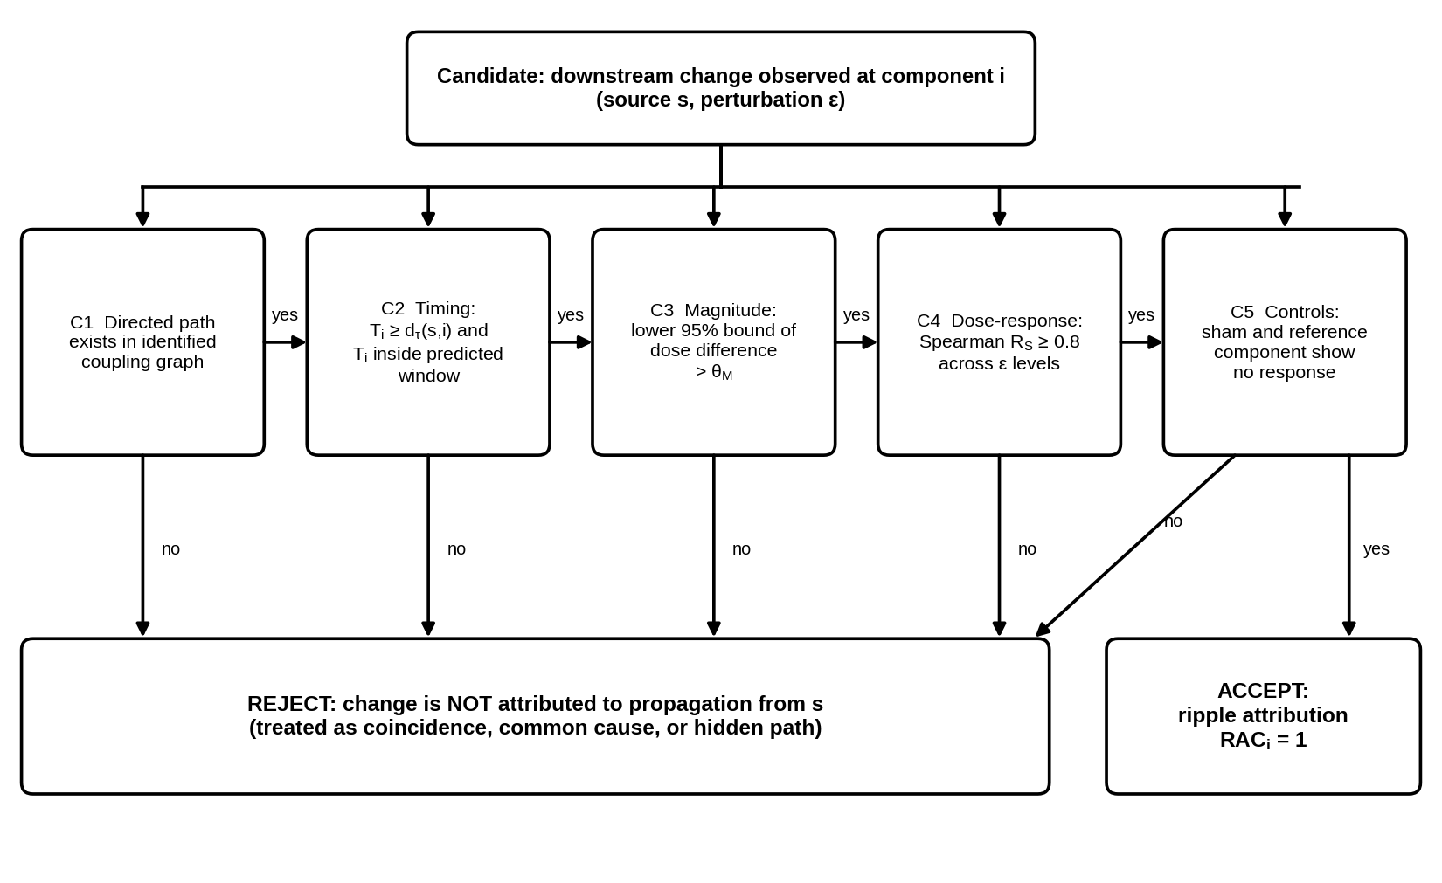
Figure 13. Decision flow of the Ripple Attribution Criterion. A downstream change is accepted as a ripple only if all five criteria hold in sequence. Failure of any one criterion rejects the attribution (Eq. (17)).

8.10 Experimental architecture: electronic network
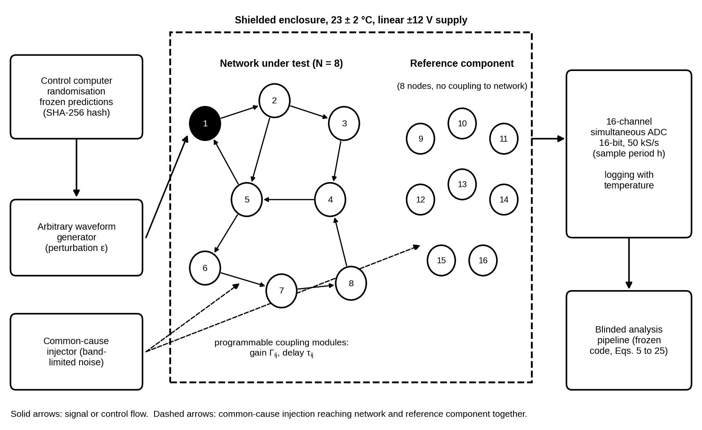
Figure 14. Architecture of the electronic coupled-node apparatus (Experiments E2 and E5). The network under test (8 nodes) and a physically separate reference component (8 nodes) are recorded together. Perturbations, randomisation, and the frozen predictions are controlled by one computer. The common-cause injector reaches both components and is used only in Experiment E5.

8.11 Experimental architecture: wave tank
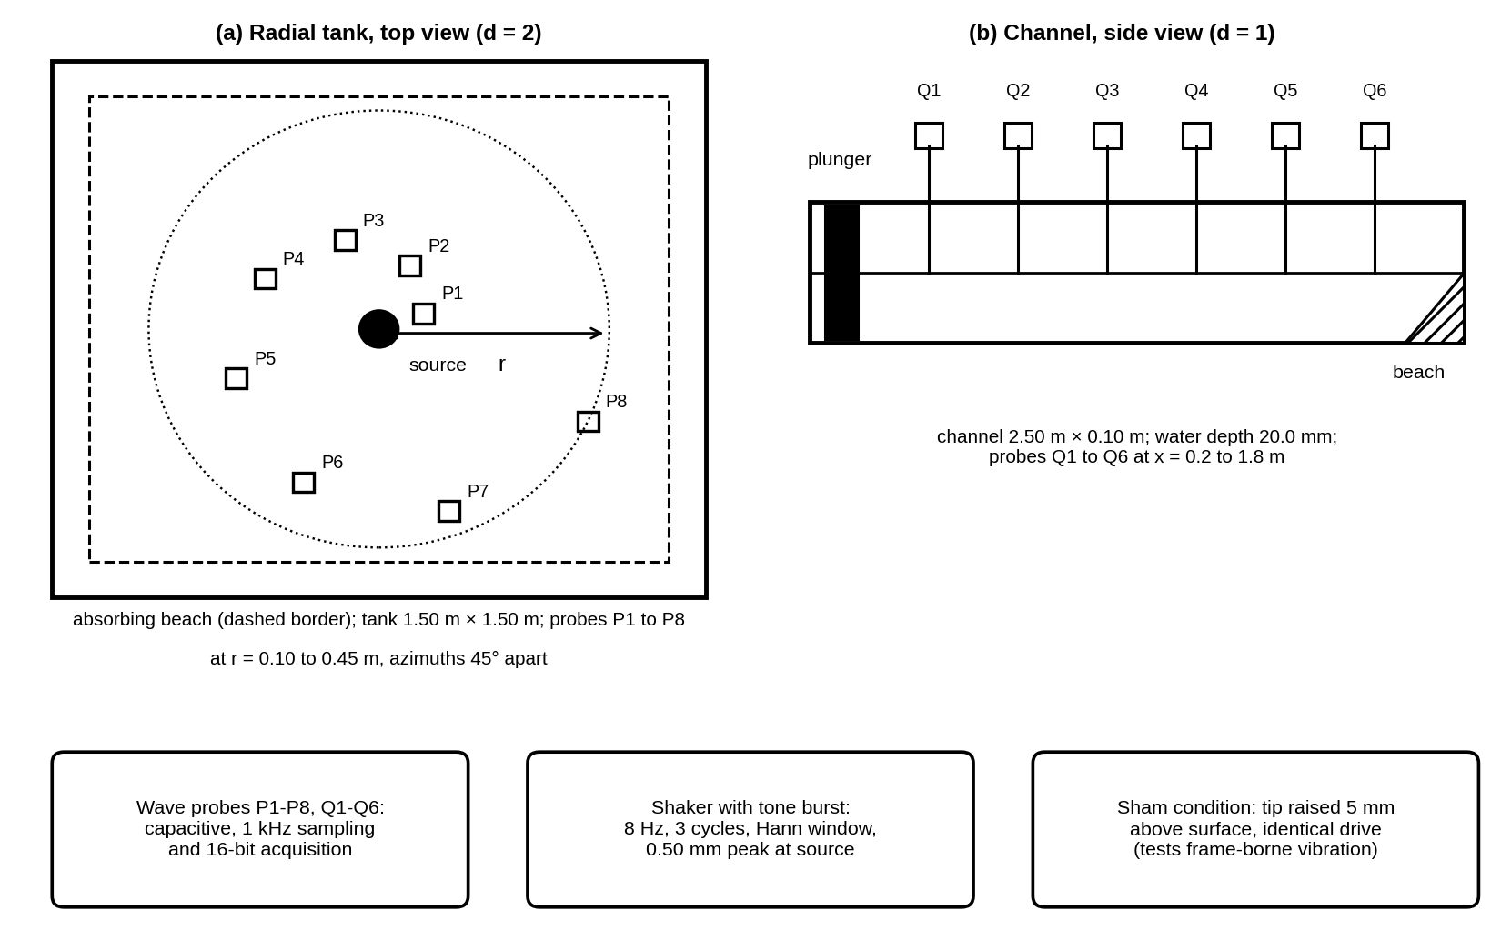
Figure 15. Layout of the radial tank and the channel (Experiment E3). Eight probes sample the radial tank at different distances and azimuths. Six probes sample the channel. The sham condition raises the source tip above the water so that any probe signal can only come from vibration carried by the frame.

8.12 Trial timing and randomisation
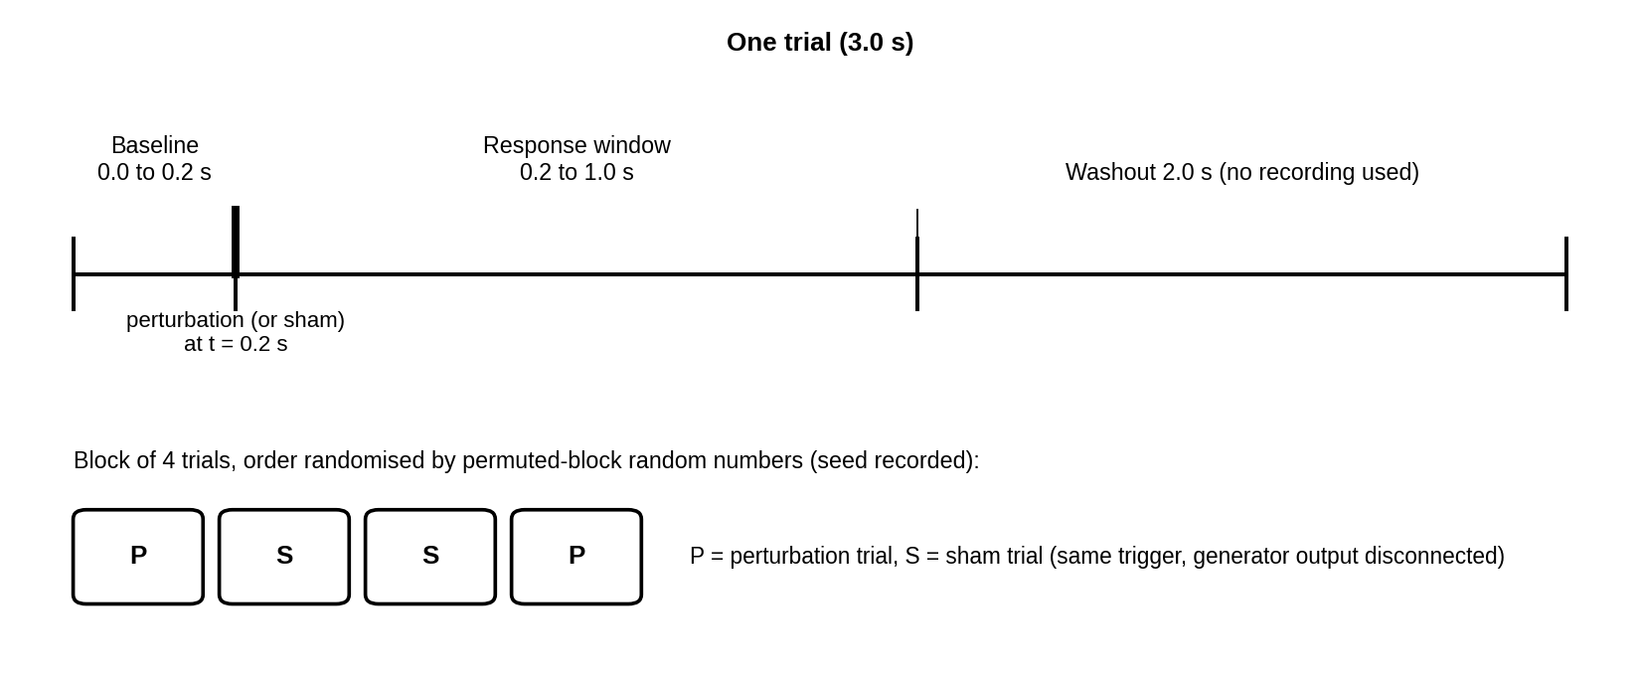
Figure 16. Timing of one trial and the order of trials within a block. Every trial lasts 3.0 s. Perturbation and sham trials share the same trigger and recording. Order within each block of four trials is set by permuted-block random numbers.

8.13 Falsification region of the parity law
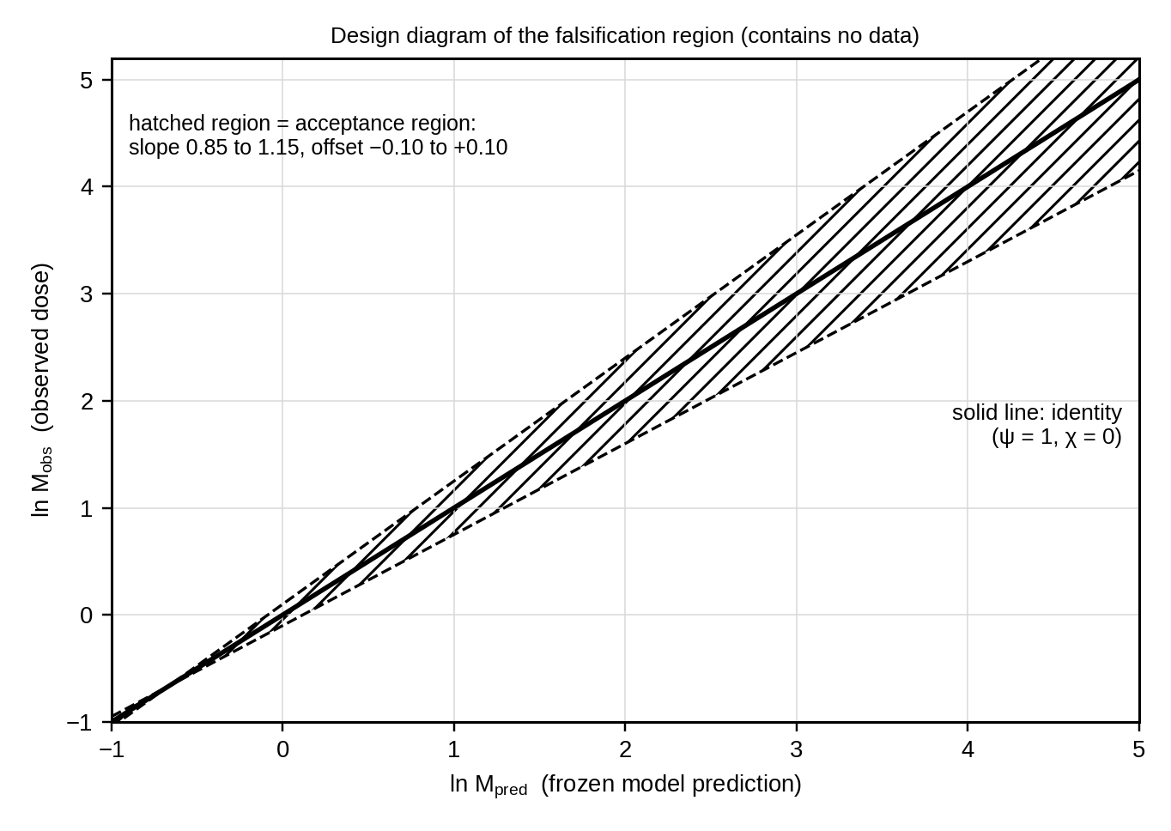
Figure 17. Acceptance region of the cross-domain parity law. A domain supports the law only if the 90% confidence interval of its parity slope lies in [0.85, 1.15] and the interval of its offset lies in [−0.10, +0.10]. The figure shows the design and contains no data.

9. INTRODUCTION, SCOPE, AND HYPOTHESES

9.1 Context
An initial event does not necessarily end with its immediate effect. A change in one component of a connected system can influence other components, which can then influence further components. Depending on the system, the consequences may diminish, persist, amplify, reverse, or return to influence the original component. Ripple Effect Theory (RET) studies this propagation process as one research problem with one set of measured quantities.

A ripple in a fluid, a disturbance in an electrical network, and a cascade of line outages in a power grid can share mathematical structure without sharing the same physics. RET therefore requires that each application states its own mechanism, its own components, and its own measurements. The theory does not assume that a model that works in one physical system explains social, biological, or historical events.

9.2 Established knowledge
The following results are established and are used here as tools. RET does not claim them as new.
- Counterfactual definitions of causal effect and the potential-outcomes framework [1, 5].
- Linear response, stability, and delay differential dynamics of coupled systems [2, 40].
- Network structure, small-world and scale-free topologies, and dynamics on networks [3, 4, 28, 29].
- A growth or decay threshold given by the spectral radius of a gain matrix: reproduction numbers in epidemics [10, 11, 12], input-output analysis in economics [13, 25], and branching-process models of cascading failure [19].
- Threshold cascades on networks and their percolation criteria [14, 15, 16].
- Geometric spreading and damping of linear waves [24].
- Temporal precedence is not sufficient for causation; evidence from dose-response, specificity, and control conditions is required [1, 38].

9.3 Hypothesis versus established fact
Table 7. Separation of established results from RET hypotheses
Topic | Established fact | RET hypothesis (to be tested)
Linear response | A linear delayed network responds with dose M = (I − A)⁻¹M⁽⁰⁾ [2, 40] | Independently measured κ_{i}, Γ_{ij}, and τ_{ij} predict observed doses with parity slope ψ = 1 ± 0.15
Growth or decay | The spectral radius of the gain matrix decides growth or decay [10, 11, 13, 40] | Ω is the single quantity that governs hop-dose decay and the critical gain in all tested domains
Timing | Effects cannot precede their causes along a path with finite delay | The bound T_{i} ≥ d_{τ}(s,i) separates propagation from common causes in practice
Loops | A feedback loop with gain below 1 produces decaying recurrences | T_{rec} and R_{rec} predict recurrence period and dose ratio within 5% and ±0.10 in ln ratio
Cascades | Threshold cascades follow a percolation-type criterion [14, 16] | Ω_{φ} > 1 predicts the cascade window and cascade generations in a power-grid model
Attribution | Precedence alone does not establish causation [1, 38] | The five-criterion RAC reaches sensitivity and specificity lower bounds of 0.90
Unity across domains | Each domain has its own validated models | A single parity law with the same slope and offset holds for electronic, fluid, and power-grid systems

9.4 Critical review of related approaches
Table 8. Related approaches and their limits relative to RET
Approach | What it establishes | Limit relative to RET
Potential outcomes and graphical causal models [1, 5] | Defines causal effect as a counterfactual contrast and gives identification rules | Does not give a dynamic propagation model with predicted timing and magnitude
Granger causality, transfer entropy, convergent cross mapping [6, 7, 8] | Detects predictive information flow in time series | Statistical association of time series; does not predict dose from independently measured couplings
Nonlinear dynamics and chaos [2, 9] | Sensitivity to initial conditions and stability analysis | Describes divergence of trajectories, not the spatial or network path of an effect
Network science [3, 4, 28, 29] | Structure of connected systems and spreading on them | Often addresses structure; attribution and cross-domain parity tests are not standard
Epidemic thresholds [10, 11, 12] | Reproduction number as a spectral radius | Domain-specific; no common attribution rule
Input-output and production networks [13, 25] | Total effect (I − A)⁻¹ of a shock in an economy | Applied to aggregate data without counterfactual lab control
Cascading failure [14, 15, 16, 17, 18, 19] | Threshold and branching models of cascades | Domain-specific; no link to linear-response and wave propagation
Wave propagation [24] | Geometric spreading and damping in media | Applies to continuous media; not to networks of discrete components
Early-warning signals and self-organised criticality [26, 27] | Statistical signatures near critical transitions | Detect proximity to transitions, not propagation of a specific disturbance
Self-exciting and synchronising systems [20, 22, 23] | Mutual excitation of events and stability of synchronised states on networks | Address statistical or synchronisation stability, not a dose-based prediction of a single disturbance
Contagion geometry and resilience patterns [34, 35] | Effective distance for spreading and universal resilience patterns of networks | Reduce complex networks to few parameters but do not give an attribution rule
Temporal networks [21] | Time-varying coupling structure | Addresses structure; RET adds a dose-based propagation measure (Section 11)

9.5 Knowledge gap
No existing framework combines four elements: a counterfactual measure of the ripple, a prediction made only from independently measured couplings, a causality bound that serves as a rejection test for hidden paths and common causes, and a pre-registered test of whether one parity law holds across physically different systems. RET supplies these four elements and states the thresholds at which each fails.

9.6 Scope and admissibility conditions
Version 1.0 of RET applies only to admissible systems. A system is admissible if it meets all five conditions below. Systems that fail any condition are outside the scope of this version, and no claim is made about them.
Table 9. Admissibility conditions
Code | Condition | How it is checked
A1 | The system is bounded and its components can be listed and measured individually | Component list and measurement channel for each component are written in the protocol
A2 | The baseline is observable and its noise can be estimated | Baseline window of at least 0.2 s or 50 samples before every perturbation
A3 | A perturbation of controllable size can be applied at a chosen component, with a sham condition | Perturbation generator with disconnect switch
A4 | Couplings κ_{i}, Γ_{ij}, and τ_{ij} can be measured independently of the ripple under test | Identification runs completed and frozen before ripple trials
A5 | Predictions, thresholds, and sample sizes are fixed before data collection | Hashed prediction file and registered protocol

Version 1.0 also requires small perturbations: the dose at twice the base perturbation must lie within 10% of twice the dose at the base perturbation (linearity check). Larger perturbations require the threshold regime of Postulate 6. Historical, social, and economic events are outside the scope of this version because their couplings cannot be measured independently under condition A4 and no sham condition exists under A3.

9.7 Research questions and hypotheses
Primary research question: for admissible systems, can the magnitude, timing, recurrence, and persistence of downstream effects be predicted from independently measured couplings, and can propagation be distinguished from coincidence and common cause? The question is answered by the six hypotheses below, each of which has a decision rule in Section 12.
Table 10. Hypotheses
ID | Statement | Postulates | Test
H0 (null) | Apparent downstream effects are adequately explained by background variation, shared causes, local dynamics, measurement error, or chance | None | All
H1 | A controlled perturbation produces downstream changes that exceed those under a sham condition at every component predicted to respond | P1, P2 | E2, E3
H2 | The observed pattern of propagation can be predicted from independently measured connections among components | P2 to P5, P8 | E2, E3, E4
H3 | Network structure and feedback explain the persistence and magnitude of downstream effects beyond a model that considers only the initial event | P3, P5 | E2
H4 | The Ripple Attribution Criterion separates true ripples from common-cause and mimicked sequences | P7 | E5
H5 | One parity law, ψ = 1 and χ = 0, holds across electronic, fluid, and power-grid systems | P8 | E4
H6 | The criterion Ω_{φ} > 1 predicts when threshold cascades are possible | P6 | E1, E4

10. FORMAL MODEL: PRIMARY POSTULATES

10.1 Model definition and measured quantity
Consider a bounded system of N components. The state x_{i}(t) of component i obeys the network equation below.

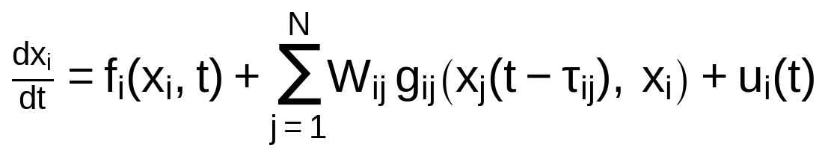 (1)

Component i has its own dynamics f_{i}. It receives influence from component j through the coupling function g_{ij}, scaled by the weight W_{ij} and delayed by τ_{ij}. It may also receive an external input u_{i}(t). A perturbation of size ε is applied at the source component s at time zero:

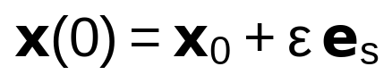 (2)

The vector e_{s} has value 1 at the source and 0 elsewhere. The measured quantity of the theory is the ripple field, the difference between the disturbed run and the baseline (counterfactual) run of the same system:

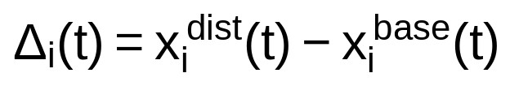 (3)

The baseline is obtained by sham trials, in which the trigger and recording are identical but the perturbation is absent. Because the same system is measured in both conditions, shared background influences cancel in Δ_{i}(t) when they act equally in both conditions. A component whose Δ_{i}(t) stays within the detection threshold throughout is classified as not reached.

10.2 Postulate 1: Coupling-conditioned propagation
Statement. A change at component s can alter component i only through a directed path of nonzero couplings from s to i. If no such path exists, the ripple field of i is zero within measurement noise. Any change at i that occurs without such a path is attributed to a common cause or to chance.

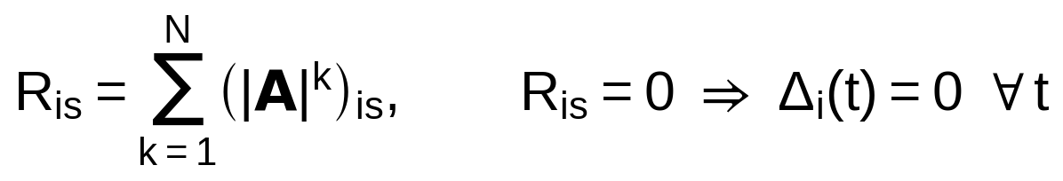 (4)

Plain-language meaning of the terms. R_{is} counts, with positive weights, all paths of up to N hops from s to i. It is positive exactly when i can be reached from s. The matrix A is defined in Postulate 2.

Testable prediction. In the disconnected reference component of the electronic apparatus, every component must satisfy |Δ_{i}| ≤ θ throughout the response window (E2, E5).

Status. The need for a coupling path is established. The hypothesis is that the identified coupling graph is complete enough to apply the statement in the tested apparatus.

10.3 Postulate 2: Linear delayed response and conserved dose
Statement. For a small perturbation, the ripple field obeys the linear delayed equation below. The integrated dose of the ripple field at every component is then given exactly by the hop-gain matrix A.

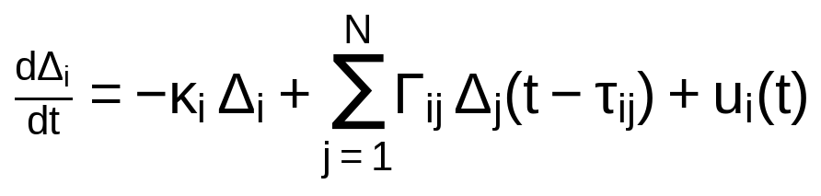 (5)

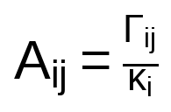 (6)

(7)

Plain-language meaning of the terms. κ_{i} is how fast component i returns to rest by itself. Γ_{ij} is how strongly the ripple at j drives i. The hop gain A_{ij} = Γ_{ij}/κ_{i} is the fraction of the dose of j that component i receives. M_{i} is the total area under the ripple curve of i. M⁽⁰⁾ is the dose that the source would accumulate alone.

Testable prediction. The dose follows from integrating Eq. (5) over all time. Delays do not change an integral, and the ripple field returns to zero, so κ_{i}M_{i} equals the sum of Γ_{ij}M_{j} plus the source term ε at i = s. Dividing by κ_{i} gives M = AM + M⁽⁰⁾, which is Eq. (7). For every reachable component the observed dose must equal the frozen prediction, with parity slope ψ within [0.85, 1.15] (E2, E4).

Status. The derivation is exact for a linear delayed system and is established mathematics [2, 40]. The hypothesis is that the apparatus is in the linear regime for the chosen ε and that κ_{i}, Γ_{ij}, and τ_{ij} can be identified accurately enough to predict doses.

10.4 Postulate 3: Ripple Number, attenuation, and amplification
Statement. The spectral radius Ω = ρ(A) decides the fate of a disturbance. For Ω < 1 the dose contributed by effects that traversed k couplings decays as Ω^{k} and the total dose is finite. For Ω = 1 the hop doses persist. For Ω > 1 they grow until a nonlinearity limits them.

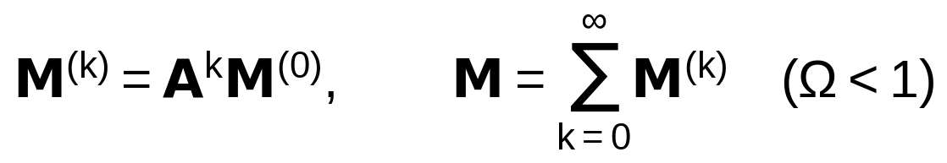 (8)

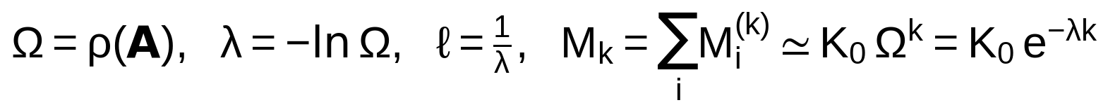 (9)

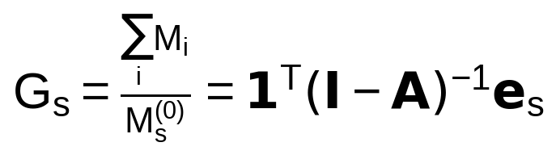 (10)

Plain-language meaning of the terms. M^{(k)} is the part of the dose that has passed through exactly k couplings. M_{k} is its sum over components. Ω is the factor by which the hop dose is multiplied at each further hop. The attenuation rate λ = −ln Ω is the same statement on a logarithmic scale, and ℓ = 1/λ is the number of hops over which the dose falls by the factor e. G_{s} is the total dose divided by the source dose.

Testable prediction. The asymptotic decay M_{k} ≃ K₀Ω^{k} holds for a nonnegative, primitive matrix A by the Perron-Frobenius theorem [40]. If the coupling graph has no loop, then A is nilpotent, Ω = 0, and the effect vanishes after at most N − 1 hops. The tests are the critical gain scale c_{g}* = 1/Ω₀ (E2) and the dose ratio between passes of a loop (E2, Postulate 5).

Status. The mathematics is established [10, 11, 13, 40]. The hypothesis is that Ω, measured from independent identification, predicts the regime and the decay of the real apparatus.

10.5 Postulate 4: Arrival time and the causality bound
Statement. A ripple cannot arrive at component i earlier than the minimum-delay path distance from the source. The arrival time is the first time at which the ripple field exceeds the detection threshold for m_{c} = 5 consecutive samples. The predicted arrival time is obtained by solving Eq. (5) numerically with the measured parameters.

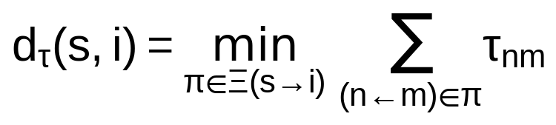 (11)

(12)

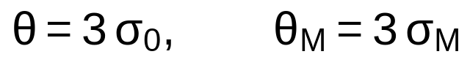 (18)

Plain-language meaning of the terms. d_{τ}(s,i) is the smallest sum of transport delays along any path from s to i. T_{i} is the detected arrival time. θ is three times the baseline noise standard deviation σ₀, and θ_{M} is three times the baseline standard deviation σ_{M} of the dose integral. For independent Gaussian samples, requiring five consecutive samples above θ gives a false-alarm probability of about 4 × 10⁻¹⁵ per detection window. Correlated noise raises this value, which is why sham trials are always recorded.

Testable prediction. In at most 5% of trials may a component show T_{i} < d_{τ}(s,i), and the median |T_{i} − T_{i}^{pred}| must not exceed the larger of 10% of the prediction and 0.5 ms for the electronic network (E2). In the wave tank no probe may detect the burst earlier than r_{i}/c_{max}, where c_{max} is the largest group speed measured in the channel (E3). An early arrival signals a hidden path or common cause.

Status. The bound follows from finite propagation delay and is established. The hypothesis is that it is a practical discriminator against vibration, grounding, and shared-input artefacts in the tested apparatus.

10.6 Postulate 5: Feedback, recurrence, and persistence
Statement. A single directed loop of couplings returns a pulse to its origin after a recurrence period equal to the loop delay. Each pass multiplies the dose by the product of the hop gains around the loop. For R_{rec} < 1 the recurrences decay and the persistence time is finite.

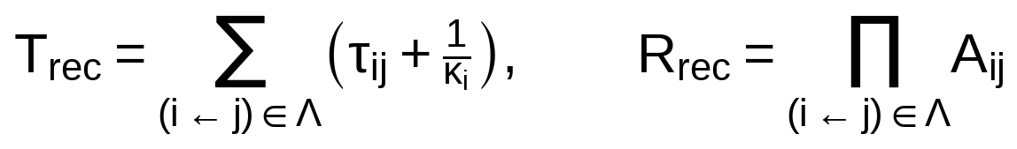 (13)

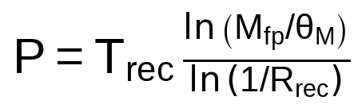 (14)

Plain-language meaning of the terms. Λ is the loop. Around the loop, each coupling contributes its transport delay τ_{ij} and the delay 1/κ_{i} of the relaxation of component i. R_{rec} is the loop gain. M_{fp} is the dose of the first pass. The persistence time P is the time until the dose of a recurrence falls below θ_{M}.

Testable prediction. The delay 1/κ_{i} is the exact mean delay (centroid delay) of a first-order relaxation, and the dose gain A_{ij} is exact by Postulate 2, so the formulas follow for a loop that is the only loop of the network. In the directed ring of E2 the measured recurrence period must lie within 5% of T_{rec}, and the natural logarithm of the measured pass-to-pass dose ratio must lie within ±0.10 of ln R_{rec}.

Status. The loop mathematics is established. The hypothesis is that the apparatus follows it within the stated limits. The statement applies to topologies with exactly one directed loop; multi-loop topologies are not claimed in version 1.0.

10.7 Postulate 6: Threshold cascades
Statement. In systems in which a component activates when the active share of its incoming weight reaches a threshold, a global cascade is possible if and only if the threshold Ripple Number Ω_{φ} exceeds 1.

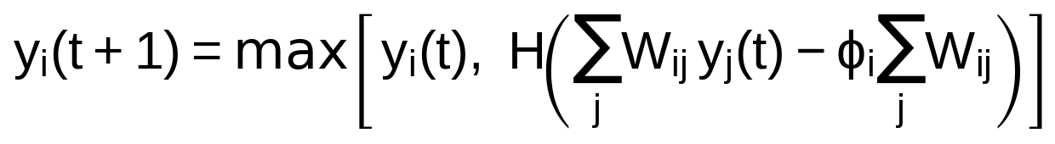 (15)

(16)

Plain-language meaning of the terms. y_{i}(t) is 1 when component i is active. H is a step that equals 1 when the active incoming weight reaches the fraction φ_{i} of the total incoming weight. B^{NB} is built on directed edges j → i for which a single active neighbour j can trigger i, and it forbids immediate backtracking of an edge. For a random graph with degree distribution p_{b}, mean degree ν, and one threshold φ, Ω_{φ} = Σ_{b=1}^{⌊1/φ⌋} b(b − 1)p_{b}/ν, which is the criterion of Watts [14] expressed with the non-backtracking matrix [16].

Testable prediction. In E1, on random graphs with φ = 0.18, the cascade frequency must be at least 0.50 at every tested mean degree in [ν_{lo} + 1.0, ν_{hi} − 1.0] and at most 0.05 for ν ≤ ν_{lo} − 0.5 and ν ≥ ν_{hi} + 0.75, where ν_{lo} = 1.04 and ν_{hi} = 5.74 are the roots of Ω_{φ} = 1. In E4 the generation counts of a power-grid cascade model must follow the parity law.

Status. The criterion is established for random graphs [14, 15, 16]. The hypothesis concerns its use as a Ripple Number within RET and its application to the power-grid cascade model.

10.8 Postulate 7: Ripple Attribution Criterion
Statement. A downstream change at component i is attributed to propagation from source s if and only if all five criteria of Table 11 are met. The attribution score is the product of the five indicators and equals 1 only when every criterion holds.

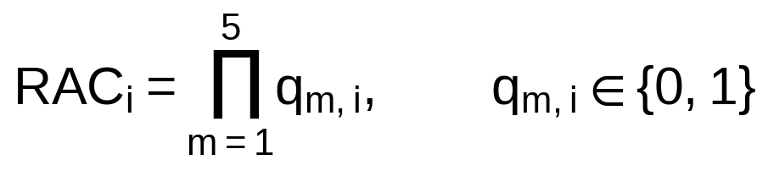 (17)

Plain-language meaning of the terms. q_{m,i} is 1 when criterion m is met at component i and 0 otherwise. The criteria require, in turn, a coupling path, correct timing, a measurable dose, a dose that rises with perturbation size, and the absence of response under controls.

Testable prediction. In E5 the lower 95% Clopper-Pearson bound [32] of sensitivity must be at least 0.90 and the lower bound of specificity must be at least 0.90, each estimated from 200 independent decision blocks.

Status. The criteria are motivated by counterfactual causal inference and by Hill-type evidence [1, 5, 38]. Their combination and numerical thresholds are hypotheses of RET.

Table 11. Criteria of the Ripple Attribution Criterion
Criterion | Condition | Operational rule
C1 Path | A directed coupling path from s to i exists | R_{is} > 0 using only couplings with |Γ_{ij}| larger than three times its identification standard error
C2 Timing | Arrival respects causality and prediction | T_{i} ≥ d_{τ}(s,i) and |T_{i} − T_{i}^{pred}| ≤ max(10% of T_{i}^{pred}, 0.5 ms)
C3 Magnitude | The ripple exceeds noise | Lower 95% bootstrap bound of (dose in perturbation trials − dose in sham trials) exceeds θ_{M}
C4 Dose-response | Larger perturbations produce larger doses | Spearman R_{S} ≥ 0.8 between perturbation size and dose over four sizes [37]
C5 Controls | Sham and reference components show no response | Sham dose at i and all doses in the reference component are at most θ_{M}

10.9 Postulate 8: Cross-domain parity law
Statement. For admissible systems of different physical kinds, the frozen predictions of RET and the observed doses obey one parity relation with slope 1 and offset 0 on the natural-logarithm scale. The law is tested separately in each domain and is supported in a domain only if the 90% confidence interval of the slope lies in [0.85, 1.15] and the interval of the offset lies in [−0.10, +0.10].

(23)

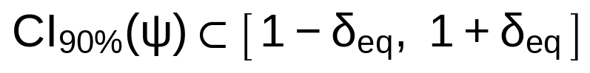 (24)

Plain-language meaning of the terms. M^{obs} is the observed response magnitude, defined for each domain in Experiment E4: the dose in networks, the gated root-mean-square amplitude in waves, and the generation count in cascades. M^{pred} is the value predicted in advance from independently measured parameters. ψ = 1 means that every factor of change in the prediction appears as the same factor in the observation. χ = 0 means no systematic over- or under-prediction. δ_{eq} is the half-width of the equivalence region.

Testable prediction. Experiment E4 estimates ψ and χ for three domains. The unified law is supported only if all three domains pass. If a domain fails, the law is withdrawn for that domain and retained for those that pass.

Status. This is the central and unproven hypothesis of RET. It is not established by existing literature.

10.10 Worked numerical example
The example uses a three-component system with relaxation rate κ_{i} = 2.0 s⁻¹ for all components, source s = 1, and perturbation ε = 1.0 [x]. The numbers are computed from the equations; they are not empirical.

Table 12. Worked example of Postulates 2 and 3
Quantity | Value
Hop-gain matrix A (rows i = 1 to 3, columns j = 1 to 3) | Row 1: 0, 0.30, 0.10. Row 2: 0.40, 0, 0.20. Row 3: 0.20, 0.30, 0
Source dose M⁽⁰⁾ = (ε/κ₁) e₁ | (0.500, 0, 0) [x]·s
Ripple Number Ω = ρ(A) | 0.498 (below 1, so the total dose is finite)
Attenuation rate λ = −ln Ω and length ℓ | 0.697 per hop and 1.44 hops
Total dose M = (I − A)⁻¹ M⁽⁰⁾ | (0.606, 0.284, 0.206) [x]·s
Amplification factor G₁ | 2.19
Hop totals M_{k} for k = 0 to 5 | 0.500, 0.300, 0.150, 0.072, 0.0372, 0.0180
Ratios M_{k+1}/M_{k} for k = 0 to 4 | 0.600, 0.500, 0.480, 0.517, 0.484 (approaching Ω = 0.498)

11. EXTENDED MECHANISMS
The extended mechanisms below add features to the primary postulates. Only X1 and X2 are used in the experiments of version 1.0. X3 and X4 are mathematical statements without claimed empirical support in this version; using them in an experiment requires a new registered protocol.

11.1 Mechanism X1: Continuous media
Statement. In a continuous medium of spatial dimension d, the amplitude of a propagating disturbance decreases with distance by geometric spreading and by damping.

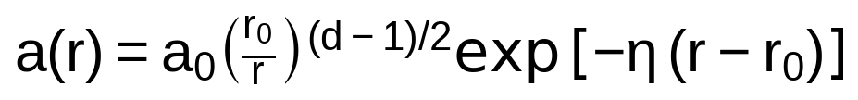 (19)

Plain-language meaning of the terms. a₀ is the amplitude at the reference distance r₀. The factor (r₀/r)^{(d−1)/2} accounts for the spreading of energy over a growing wavefront: it equals 1 for a plane wave (d = 1), 1/√r for a circular wave (d = 2), and 1/r for a spherical wave (d = 3). The factor exp[−η(r − r₀)] is damping with coefficient η. For d = 1 the formula reduces to the exponential law of the original working draft.

Testable prediction. In E3 the fitted spreading exponent (d − 1)/2 must have a 90% confidence interval inside [0.40, 0.60] for the radial tank and inside [−0.10, +0.10] for the channel.

Status. Established for linear damped waves [24]. The hypothesis is the use of the same parity format as for networks.

11.2 Mechanism X2: Stochastic ripple
Statement. When components are driven by white noise of intensity Q, the baseline fluctuation has a stationary covariance C that solves the matrix equation below, and the detection threshold follows from its diagonal.

(20)

Plain-language meaning of the terms. J is the Jacobian of the linear system without delays. C is the covariance of the fluctuations around the baseline, and its diagonal element C_{ii} is the variance σ_{0,i}² of the noise at component i. The relation holds for delays small compared with 1/κ_{i} [39].

Testable prediction. In E2 the baseline standard deviations predicted from Eq. (20), with Q measured on isolated components, must agree with the measured values within 20% (secondary outcome, reported without a hypothesis claim).

Status. The equation is established [39]. The use of the predicted noise level for threshold setting is a methodological choice of RET.

11.3 Mechanism X3: Time-varying couplings
Statement. If the couplings change in L ordered steps, the long-run growth factor per step is the geometric-mean spectral radius of the product of the snapshots.

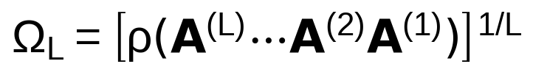 (21)

Plain-language meaning of the terms. A^{(l)} is the hop-gain matrix during the l-th step, applied in order l = 1 to L. Ω_{L} < 1 means that the dose decays over a full cycle of the sequence even if a single snapshot has Ω ≥ 1.

Testable prediction. Not tested in version 1.0.

Status. Mathematical statement based on the theory of temporal networks [21]; no empirical support is claimed.

11.4 Mechanism X4: Interdependent layers
Statement. For Y coupled layers, such as a power layer and a communication layer, the hop-gain matrix is a block matrix, and the Ripple Number is its spectral radius.

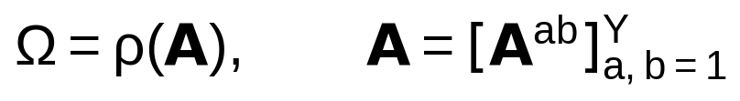 (22)

Plain-language meaning of the terms. A^{ab} is the block that couples layer b to layer a. Cross-layer blocks allow a disturbance to move between layers. Interdependence can raise Ω above the value of either layer alone [18].

Testable prediction. Not tested in version 1.0.

Status. Mathematical statement; no empirical support is claimed.

12. EXPERIMENTAL PROGRAMME AND FALSIFICATION
This section specifies five experiments. Every apparatus value, sample size, and decision threshold is fixed here, before any data are collected. An experiment gives one of two outcomes: supported or not supported. An experiment that cannot be completed under the rules below counts as not supported. This design follows the principle that a theory must state in advance what observation would refute it [33].

12.1 Common design rules
Table 13. Rules that apply to all experiments
Rule | Specification
Registration | The protocol of this section is registered with a public preregistration service (Open Science Framework) with a date stamp before the identification runs of E2 begin.
Frozen predictions | All predictions are computed from independently measured parameters and written to one file. The SHA-256 hash of the file is recorded in the registration before any ripple trial is run.
Blinding | Trial files carry coded identifiers. The analyst does not know which files are perturbation or sham trials until the analysis code is frozen and hashed.
Randomisation | Trial order is set by permuted blocks. The random seed is the first 8 hexadecimal digits of the hash of the frozen prediction file, converted to an integer, and is recorded.
Detection | θ = 3σ₀ and θ_{M} = 3σ_{M}, estimated from the baseline window of each trial. A detection needs m_{c} = 5 consecutive samples above θ.
Statistics | Intervals are percentile bootstrap intervals with 10,000 resamples; the resampling unit is the trial. Equivalence uses the 90% interval (Eq. (24)). Proportions use Clopper-Pearson intervals [32]. Bootstrap methods follow Efron and Tibshirani [31] and equivalence follows Schuirmann [30].
Multiplicity | Each primary outcome is one pre-specified decision about one postulate. The framework-level claim requires all primary decisions to pass, so no adjustment of intervals is applied (intersection-union principle). Secondary outcomes are reported with 95% intervals and carry no hypothesis claim.
Sample size | Eq. (25) with α = 0.05, β = 0.10, σ_{plan} = 0.25, and δ_{eq} = 0.15 gives n ≥ 30.06, so n = 31. The design uses n = 32 trials per condition to fit blocks of four. If the observed standard deviation of the per-trial estimate exceeds 0.25, the experiment is declared underpowered and counts as not supported.
Exclusions | A trial is excluded only for pre-specified quality flags: converter clipping, supply voltage outside ±5% of nominal, temperature outside 23 ± 2 °C (electronic) or 20.0 ± 0.5 °C (tank), or a logged operator event. Excluded trials are replaced by new trials in the same block. If more than 10% of trials in a condition are excluded, the condition is repeated once in full. A second failure counts as not supported.
Deviations | Every deviation from this protocol is logged with date and reason and reported in the final report. A deviation from a threshold or sample size makes the affected experiment not supported.
Order and gate | E1 is run first. If E1 is not supported, E2 to E5 are not started until the fault is corrected and E1 is repeated once. The order after E1 is E2, E5, E3, then E4.

12.2 Experiment E1: Computational verification
Table 14. Experiment E1: Computational verification
Item | Specification
Tests | Mathematical statements of Postulates 2, 3, and 6 as implemented in the analysis code (H2 in part, H6)
Apparatus and materials | Python 3 with NumPy and SciPy in double precision on one computer; versions and random seeds recorded. Graph families: Erdős-Rényi, Watts-Strogatz (6 neighbours, rewiring probability 0.1) [28], and Barabási-Albert (3 links per new node) [29], each with N = 200. Weights are drawn uniformly on (0, 1), scaled so that Ω equals 0.5, 0.7, or 0.9; κ_{i} = 1 and τ_{ij} is uniform on 0.5 to 1.5.
Procedure | (1) For 1,000 graphs per family and Ω, compute the dose from (I − A)⁻¹M⁽⁰⁾ and the hop totals M_{k} for k = 0 to 40. (2) For 100 graphs per family and Ω, integrate Eq. (5) with a fourth-order Runge-Kutta scheme, step 0.005, to t = 1,500 and integrate the ripple field to obtain M_{i}. (3) Simulate the threshold rule Eq. (15) with φ = 0.18 on Erdős-Rényi graphs with N = 10,000 and mean degree ν from 0.25 to 9.00 in steps of 0.25: 10 graphs per ν and 200 single-seed runs per graph. A run is a cascade if more than 5% of components become active.
Primary outcome | All three checks below are met.
Analysis | Check 1: for every graph in step 2, the largest relative difference between the integrated dose and (I − A)⁻¹M⁽⁰⁾ over components with dose above 10⁻⁶M⁽⁰⁾ is at most 10⁻³. Check 2: for every graph in step 1 with primitive A, the slope of ln M_{k} for k = 20 to 40 differs from ln Ω by at most 0.02. Check 3: the cascade frequency is at least 0.50 at every tested ν in [2.04, 4.74] and at most 0.05 for every tested ν ≤ 0.54 and ν ≥ 6.49, where 1.04 and 5.74 are the roots of Ω_{φ} = 1.
Falsification threshold | Any check not met means that the computational form of the affected postulate is not supported. A second reviewer audits the code once and E1 is repeated once. Two failures end support for the affected postulate.
Alternative explanations excluded | Integration error (step halving gives the same result to 10⁻⁴); a coding fault (an independent implementation by the second reviewer must reproduce Check 1); finite-size effects (N = 10,000 and 2,000 runs per ν).
Ethics and safety | No human participants, animals, or hazardous materials. The illustration in Section 8.7 used N = 3,000 and different seeds; it was generated while drafting and is not part of E1.

12.3 Experiment E2: Electronic coupled-node network
Table 15. Experiment E2: Electronic coupled-node network
Item | Specification
Tests | Postulates 1 to 5 and Extended Mechanism X2; hypotheses H1, H2, H3
Apparatus | Sixteen node boards, each a first-order operational-amplifier stage with R = 2.00 kΩ (0.1%) and C = 100 nF (1%), giving a nominal relaxation rate κ = 5,000 s⁻¹. Programmable coupling modules provide gain 0 to 1.5 in steps of at most 0.005 and a buffered delay of 1.0 to 50.0 ms in steps of 0.02 ms. An analogue crosspoint switch sets the topology. An arbitrary waveform generator (16 bit) supplies a 0.500 V pulse of width 50 μs at the source. A simultaneous-sampling 16-bit converter records all 16 nodes at 50 kS/s (h = 20 μs). The assembly is in a shielded enclosure at 23 ± 2 °C on a linear ±12 V supply. Eight nodes form the network under test and the other eight form a reference component with no coupling to it (Figure 14).
Topologies | T1: a directed ring of 6 nodes with delay 5.0 ms per coupling, so T_{rec} = 6 × (5.0 ms + 0.2 ms) = 31.2 ms, and gains a = 0.5, 0.7, and 0.9 (R_{rec} = a⁶ = 0.0156, 0.1176, 0.5314). T2: the 8-node network of Figure 14 with directed couplings 1→2, 2→3, 3→4, 4→5, 5→1, 5→6, 6→7, 7→8, 8→4, and 2→5 with delays 4, 5, 6, 7, 8, 9, 10, 11, 12, and 13 ms in this order, so d_{τ}(1, i) is 4, 9, 15, 17, 26, 36, and 47 ms for nodes 2 to 8. The nominal gain is 0.30 for every coupling (nominal Ω₀ = 0.389). T2 is run at gain-scale levels c_{g}Ω₀ = 0.50, 0.70, 0.85, 0.95, 1.05, 1.20, and 1.50, and the source is node 1 in both topologies.
Procedure | (1) Identification: measure κ_{i} by step response, Γ_{ij} by small-signal sinusoids at 50 Hz with 10 repeats, and τ_{ij} by cross-correlation, for every node and coupling. (2) Compute A, Ω₀, d_{τ}, and all predictions, including the predicted arrival times from Eq. (5), and freeze them. (3) Run trials of 3.0 s (Figure 16): 0.2 s baseline, perturbation or sham at 0.2 s, response window to 1.0 s, washout of 2.0 s. For every condition record 32 perturbation trials and 32 sham trials in permuted blocks of four. (4) Linearity series: at c_{g}Ω₀ = 0.50 in T2, record 32 trials at each of the perturbation sizes 0.5, 1.0, 1.5, and 2.0 times the base pulse.
Primary outcome | Parity slope ψ and offset χ (Eq. (23)) over all pairs of (condition, node) with predicted dose at least 5θ_{M}, using the subcritical conditions: T1 at the three gains and T2 at c_{g}Ω₀ = 0.50, 0.70, 0.85, and 0.95.
Secondary outcomes | (a) H1: for every node with predicted dose at least 5θ_{M}, the lower 95% bound of (dose in perturbation trials − dose in sham trials) exceeds θ_{M}. (b) Arrival times against predictions and the causality bound. (c) Recurrence period and pass-to-pass dose ratio in T1, and persistence time at a = 0.9. (d) Regime classification: for each T2 level with a predicted late-to-peak ratio r_{end} outside 0.35 to 0.65, the share of trials whose observed r_{end} falls on the predicted side of 0.50. Here r_{end} is |Δ₁| at 0.9 s divided by its peak. (e) H3: ratio of the root-mean-square error of ln dose of the full model to that of an initial-event-only model that keeps only direct couplings of the source. (f) Linearity check of Section 9.6. (g) Baseline noise against Eq. (20). (h) Negative control: in the reference component the 90% interval of the dose difference between perturbation and sham trials lies inside [−θ_{M}, +θ_{M}] for all 8 nodes.
Analysis | Dose is the time integral of the baseline-corrected response over 0.2 to 1.0 s. ψ and χ are ordinary least-squares estimates over the (condition, node) pairs. The percentile bootstrap resamples trials within each cell, recomputes cell means, and re-estimates ψ and χ. The model has no fitted parameters.
Falsification thresholds | H2 is not supported if the 90% interval of ψ is not inside [0.85, 1.15] or the 90% interval of χ is not inside [−0.10, +0.10]. H1 is not supported if any must-respond node fails secondary outcome (a). Postulate 4 is not supported if more than 5% of trials show T_{i} < d_{τ}(1, i), or if the median absolute error of arrival time exceeds the larger of 10% of the prediction and 0.5 ms. Postulate 5 is not supported if the recurrence period differs from T_{rec} by more than 5% or if the logarithm of the dose ratio differs from ln R_{rec} by more than 0.10. Postulate 3 is not supported if the regime concordance in (d) is below 90% at any qualifying level. H3 is not supported if the upper 95% bound of the error ratio in (e) is at least 0.80. A failed negative control (h) voids the session; the session is repeated once, and a second failure means H1 is not supported.
Alternative explanations excluded | Ground loops and shared-supply coupling (reference component and separate linear supply; crosstalk between channels measured at −80 dB or lower before every session); component drift (identification repeated at the end of each session, and a session is voided if any κ_{i} or Γ_{ij} changed by more than 2%); converter clipping (trial excluded); delay quantisation (delays measured, not assumed); temperature (logged).
Ethics and safety | Low-voltage electronics (±12 V). No human participants or animals. Standard electrical safety practice and lead-free solder.

12.4 Experiment E3: Fluid surface-wave tank
Table 16. Experiment E3: Fluid surface-wave tank
Item | Specification
Tests | Postulates 1 and 4 and Extended Mechanism X1; hypotheses H1 and H2
Apparatus | An acrylic tank of 1.50 m × 1.50 m with 0.10 m walls, filled with deionised water (conductivity below 5 μS/cm) to 20.0 ± 0.2 mm at 20.0 ± 0.5 °C, on a vibration-isolated table. An absorbing beach with reflection coefficient at most 0.05, measured before the first run. An electromagnetic shaker with a 4 mm stainless-steel tip delivers a tone burst of 8 Hz, 3 cycles, Hann window, 0.50 mm peak at the source. Eight capacitive wave probes (resolution 10 μm or better, sampled at 1 kHz) at r = 0.10, 0.15, 0.20, 0.25, 0.30, 0.35, 0.40, and 0.45 m, at azimuths 45° apart. A channel of 2.50 m × 0.10 m with a plunger across its width and six probes at x = 0.20, 0.52, 0.84, 1.16, 1.48, and 1.80 m (Figure 15).
Procedure | (1) Calibrate every probe with five static depth changes of ±1 mm and require a linear fit with R² ≥ 0.999. (2) Skim the surface and rest for 10 minutes before each session; rest 120 s between runs. (3) In the channel record 32 perturbation and 32 sham runs and estimate the front speed from successive probes; c_{max} is the mean of the 32 estimates plus three standard deviations. (4) In the radial tank record 32 perturbation and 32 sham runs in permuted blocks, with probe-to-radius assignment rotated over four sessions of 8 runs so that each probe visits four radii. The sham condition raises the tip 5 mm above the water with an identical drive. (5) Odd-numbered perturbation runs are the calibration half and even-numbered runs are the test half.
Primary outcome | The fitted spreading exponent n of ln a = ln a₀ − n ln(r/r₀) − η(r − r₀) in the radial tank (prediction n = 0.5) and in the channel (prediction n = 0).
Secondary outcomes | (a) H1: at each of the 8 radii the lower 95% bound of the amplitude difference (perturbation minus sham) exceeds θ. (b) Arrival times against r_{i}/c_{max}. (c) The damping coefficient η in both geometries. (d) Parity data for E4: with n fixed at 0.5 and η fitted on the calibration half, predicted amplitudes for the test half.
Analysis | Amplitude a_{i} is the root-mean-square value of the probe signal over the gate from T_{i} to T_{i} + 0.5 s, after subtraction of the mean sham amplitude. T_{i} follows Eq. (12). The exponent and η are fitted by nonlinear least squares in each bootstrap resample of runs. The gate ends before the first reflection returns.
Falsification thresholds | The spreading law is not supported if the 90% interval of n for the radial tank is not inside [0.40, 0.60], or if the 90% interval of n for the channel is not inside [−0.10, +0.10]. H1 is not supported if any radius fails (a). Postulate 4 is not supported if any probe detects the burst before r_{i}/c_{max} in more than 5% of runs.
Alternative explanations excluded | Reflections (beach and gating); frame-borne vibration (sham condition and isolation table); surface contamination (skimming and 10-minute rest; surface tension checked before and after each session by a drop-weight method and the session is voided if it changes by more than 5%); probe bias (rotation of probes over radii); meniscus effects (probe calibration).
Ethics and safety | No human participants or animals. Water spill and electrical separation: the shaker and probe electronics are outside the tank and fitted with a ground-fault circuit breaker.

12.5 Experiment E4: Cross-domain parity test
Table 17. Experiment E4: Cross-domain parity test
Item | Specification
Tests | Postulate 8 and Postulate 6 (power-grid part); hypotheses H5 and H6
Domains | S1: the electronic network of E2. S2: the wave tank of E3 (radial tank, test half). S3: a cascading-failure model of the IEEE 118-bus transmission test case (public data), solved with an alternating-current power-flow solver (software and version recorded) with branching-process estimation of generation counts [19].
Response magnitude M | S1: dose. S2: gated root-mean-square amplitude. S3: the number of line trips N_{k} at cascade generation k.
S3 procedure | Line rating equals 1.10 times the base-case apparent-power flow, with a minimum of 30 MVA. Scenarios: each of the 186 lines is the initial outage, at load scale factors 0.9, 1.0, 1.1, and 1.2, with five random load-noise seeds (±5% per bus), giving 3,720 scenarios. Generation g + 1 consists of the lines whose loading exceeds 100% of rating after generation g is removed. Islands without generation are dropped, and islands with generation are rebalanced by proportional scaling. A power flow that fails to converge is a blackout of that island. Scenarios with an odd index in a fixed random ordering (seed recorded) form the training set and the others the test set.
Predictions | S1 and S2: the frozen predictions of E2 and E3. S3: Ω̂ is the total number of trips in generations 2 and later divided by the total in generations 1 and later in the training set, and the prediction for the test set is ln(N̄_{k}/N̄₁) = (k − 1) ln Ω̂ for k = 1 to 6, where N̄_{k} is the mean over all test scenarios. Generations with fewer than 30 trips in total are dropped. If fewer than 5% of scenarios reach generation 3, the tolerance is changed once to 1.05. If the shortfall remains, S3 is declared non-informative and the claim of E4 is restricted to two domains.
Primary outcome | For each domain the parity slope ψ and offset χ (Eq. (23)).
Analysis | Ordinary least squares on the pairs (ln M^{pred}, ln M^{obs}); percentile bootstrap with 10,000 resamples of trials (S1, S2) or scenarios (S3).
Falsification thresholds | A domain supports the parity law if the 90% interval of ψ is inside [0.85, 1.15] and the 90% interval of χ is inside [−0.10, +0.10]. The unified law (H5) is supported only if every informative domain supports it. If one domain fails, the law is withdrawn for that domain and the scope of RET is reduced to the domains that pass. H6 is supported in the power-grid model only if S3 passes.
Alternative explanations excluded | Circularity in S3 (training and test sets are disjoint); circularity in S2 (calibration and test halves are disjoint); circularity in S1 (all parameters come from the identification runs); selective reporting (all three domains are reported whatever the outcome).
Ethics and safety | Uses E2 and E3 data and public simulation data. No human participants.

12.6 Experiment E5: Attribution and common-cause test
Table 18. Experiment E5: Attribution and common-cause test
Item | Specification
Tests | Postulate 7; hypothesis H4
Apparatus | The apparatus of E2 with the common-cause injector (band-limited Gaussian noise, 0 to 2 kHz, 5 mV root-mean-square) reaching all 16 nodes. Topology T2 at c_{g}Ω₀ = 0.70 with the reference component. The target component is node 8 (d_{τ} = 47 ms), whose predicted dose is at least 5θ_{M}.
Conditions | A (true ripple): perturbation at node 1, couplings on. B (common cause): the injector delivers one pulse to all 16 nodes at once; node 1 is not perturbed; couplings on. C (mimic): all couplings set to zero; delayed copies of the predicted ripple of each node are injected at each node, with delays d_{τ}(1, i) and the predicted amplitude, so the sequence imitates propagation. E (unreachable): perturbation at node 1 with couplings on; the target is node 9, in the reference component.
Procedure | A decision block contains four perturbation trials at 0.5, 1.0, 1.5, and 2.0 times the base pulse and one sham trial, in random order. Identification runs (as in E2) precede every group of 20 blocks, with the couplings in the state of the condition under test. The five criteria of Table 11 are evaluated for each block on the target node. The design has 200 blocks of condition A, 70 blocks of B, 70 of C, and 60 of E, so 400 blocks and 2,000 trials in total.
Truth labels | Condition A blocks are true ripples. Blocks of B, C, and E are not ripples by construction.
Primary outcome | Sensitivity Se = share of A blocks with RAC = 1 and specificity Sp = share of B, C, and E blocks with RAC = 0.
Secondary outcomes | Specificity separately for B, C, and E with Clopper-Pearson intervals; the first criterion that rejects each non-ripple block.
Analysis | All criteria use rules fixed in Table 11. The analyst is blind to the condition of each block until the analysis code is frozen. Intervals for Se and Sp are Clopper-Pearson intervals [32]. For example, 195 correct decisions in 200 blocks give a lower 95% bound of 0.948, and 190 give 0.917.
Falsification threshold | H4 is not supported if the lower 95% bound of Se is below 0.90 or the lower 95% bound of Sp is below 0.90.
Alternative explanations excluded | Drift between identification and trials (identification repeated per 20 blocks); analyst expectation (blinding); order effects (random order within blocks and random order of blocks across conditions); non-independence of blocks (each block is a separate decision unit and trials are not shared between blocks).
Ethics and safety | As for E2.

12.7 Summary of decision thresholds
Table 19. Summary of hypotheses, metrics, and decision thresholds
Hypothesis | Experiment | Metric | Supported if | If not supported
H1 | E2, E3 | Lower 95% bound of the response difference at must-respond components | Above θ_{M} (E2) or θ (E3) at every such component | Propagation claim withdrawn for that apparatus
H2 | E2, E3, E4 | ψ and χ of the parity law | 90% interval of ψ in [0.85, 1.15] and of χ in [−0.10, +0.10] | Prediction from independent couplings withdrawn for that domain
H3 | E2 | Upper 95% bound of the error ratio of full model to initial-event-only model | Below 0.80 | Structure and feedback claim withdrawn
H4 | E5 | Lower 95% bounds of Se and Sp | Both at least 0.90 | Attribution criterion withdrawn
H5 | E4 | ψ and χ in every informative domain | All domains pass | Parity law withdrawn for failing domains
H6 | E1, E4 | Cascade frequency pattern; S3 parity | E1 Check 3 met and S3 passes | Threshold criterion withdrawn
Postulate 4 | E2, E3 | Share of arrivals earlier than the causality bound | At most 5% | Causality-bound claim withdrawn
Postulate 5 | E2 | Recurrence period error and ln dose-ratio error | Within 5% and within ±0.10 | Loop law withdrawn
Postulate 3 | E2 | Regime concordance | At least 90% at each qualifying level | Ripple Number claim withdrawn for the apparatus
Spreading law X1 | E3 | Exponent n | Radial in [0.40, 0.60]; channel in [−0.10, +0.10] | Continuous-medium extension withdrawn

12.8 Execution order and dependencies
Table 20. Order of execution
Step | Activity | Condition to proceed
1 | Register protocol; freeze analysis code | Registration receipt and code hash recorded
2 | Run E1 | All three checks met
3 | E2 identification and prediction freeze | Hash of prediction file recorded
4 | E2 trials | Quality rules of Section 12.1 met
5 | E5 trials | Apparatus identification stable within 2%
6 | E3 trials | Probe calibration R² ≥ 0.999; beach reflection at most 0.05
7 | E4 analysis | E2, E3, and S3 data complete
8 | Final report | All experiments reported whatever the outcome

13. COMPARISON WITH EXISTING FRAMEWORKS AND NOVELTY PROTOCOL

13.1 Comparison
Table 21. Comparison of RET with standard frameworks
Factor | Standard models | RET position
Scope | Each framework is tied to one domain | Bounded to admissible systems (Section 9.6) and tested in three domains
Causal attribution | Association measures or identification rules [1, 5, 6, 7] | Five-criterion rule with a causality bound and numerical thresholds
Magnitude | Domain-specific response functions | Dose from independently measured couplings, M = (I − A)⁻¹M⁽⁰⁾
Time | Lags estimated from data | Arrival bounded by d_{τ} and predicted from measured delays
Feedback | Stability analysis | Recurrence period and ratio as measurable predictions
Nonlinearity | Threshold models [14, 36] | Threshold Ripple Number Ω_{φ} within the same formalism
Cross-domain claim | Usually not tested | Parity law with equivalence thresholds in three domains
Falsifiability | Varies | Every postulate has a numerical failure condition (Section 12.7)

13.2 Statement on Ω and originality
The Ripple Number Ω is the spectral radius of a gain matrix. It is the same mathematical object as the reproduction number of the next-generation matrix [11], the Leontief inverse condition [13], the mean offspring number of a branching process [19], and the linear stability criterion [2]. RET does not claim Ω as a new quantity. What the manuscript proposes as new is the combination of the counterfactual ripple field, the dose-based prediction from independently measured couplings, the causality bound as a rejection test, the five-criterion attribution rule, and the pre-registered parity test across domains. This claim of novelty depends on the literature search defined below.

13.3 Novelty verification protocol
Table 22. Literature search protocol for the novelty claim
Item | Specification
Databases | Scopus, Web of Science, Google Scholar, arXiv, IEEE Xplore, and the American Physical Society journals
Search window | From 1 January 1900 to the date of the search
Search strings | (1) ("ripple effect" OR "propagation of disturbances") AND ("causal attribution" OR counterfactual) AND (network OR "dynamical system"). (2) ("spectral radius" OR "reproduction number") AND cascade AND ("cross-domain" OR "universal"). (3) ("perturbation propagation") AND (parity OR "equivalence test" OR preregistered).
Inclusion | Peer-reviewed articles, books, and preprints that contain at least one of the four elements of the knowledge gap in Section 9.5
Decision rule | If one source contains all four elements, the claim of novelty for the combination is withdrawn and the manuscript is retitled as a synthesis of established methods. If no source contains all four, the claim is kept and the numbers of records screened and included are reported.
Status | The protocol is fixed. The search has not been executed in this version. Until it is executed and recorded, the novelty of the combination is a claim and is not a finding.

14. RESULTS
No empirical data have been collected for this manuscript. No experiment of Section 12 has been run. Every cell of Table 23 therefore states that no observed value exists. No result, confirmation, or support for the theory is claimed.
Table 23. Results by experiment
Experiment | Primary outcome | Observed value | Interpretation
E1 | Three computational checks | No data collected; no observed value exists | None; the checks have not been run
E2 | Parity slope ψ and offset χ; secondary outcomes (a) to (h) | No data collected; no observed value exists | None; the apparatus has not been run
E3 | Spreading exponent n in the radial tank and the channel | No data collected; no observed value exists | None; the tank has not been run
E4 | Parity slope and offset in each of three domains | No data collected; no observed value exists | None; no domain has been analysed
E5 | Sensitivity and specificity of the attribution criterion | No data collected; no observed value exists | None; no block has been recorded

14.1 Analytic results derived in this manuscript
The following statements are derived from the equations and are mathematical results, not observations. (1) The dose of a linear delayed network is M = (I − A)⁻¹M⁽⁰⁾ because relaxation and delay conserve the area of a pulse (Section 10.3). (2) For a nonnegative primitive A the total hop dose scales as Ω^{k}, so λ = −ln Ω (Section 10.4). (3) The worked example in Table 12 gives Ω = 0.498 and G₁ = 2.19. (4) In a single directed loop the recurrence period is the sum of delays and the dose ratio is the product of gains, and the model-computed ring of Figure 10 reproduces R_{rec} = 0.2401 to four digits. (5) For random graphs with φ = 0.18 the criterion Ω_{φ} > 1 holds for 1.04 < ν < 5.74.

15. DISCUSSION, LIMITATIONS, AND PLANNED VERSIONS

15.1 Interpretation
RET states that a disturbance of a bounded system can be followed through its couplings with a small set of measured quantities. The framework gives a ripple a definition that can fail: a downstream change is a ripple only if a coupling path exists, its timing respects the causality bound, it exceeds the noise, it grows with the size of the perturbation, and it is absent under control conditions. A sequence of events that does not meet these criteria is not described as a ripple by this theory. The theory therefore does not state that every later event is caused by an earlier one.

The strongest claim of the theory is the parity law of Postulate 8. If it holds, the same few quantities (A, Ω, d_{τ}, T_{rec}) describe an electronic network, a surface wave, and a power-grid cascade with the same prediction error structure. If it holds only in some domains, the result is a more modest and still useful statement: RET applies in the domains that pass.

15.2 Consequences of each possible outcome
Table 24. Decision matrix for the experimental outcomes
Outcome | Consequence for RET version 1.0
E1 not supported | Computational forms of the affected postulates are not supported; E2 to E5 do not proceed until the fault is corrected (Section 12.1).
E2 and E3 supported, E4 supported in all three domains | The parity law is supported for the tested systems. Version 2.0 reports the result and extends the scope only by a new registered protocol.
E2 and E3 supported, E4 supported in two domains | The parity law is withdrawn for the failing domain and retained for the two that pass.
E2 or E3 not supported | The prediction from independently measured couplings is withdrawn for that apparatus, and the failing postulate is named by the thresholds of Section 12.7.
E5 not supported | The attribution criterion is withdrawn. Postulates 1 to 6 remain testable without it.
All experiments not supported | RET version 1.0 is rejected as a predictive framework. The null hypothesis H0 is retained.

15.3 Limitations and how each is bounded
Table 25. Limitations and handling
Limitation | Handling in this manuscript
A broad theory can become too general to falsify, because almost any sequence can be described afterwards as a ripple | Predictions and thresholds are frozen before testing; the attribution rule rejects sequences without a coupling path, correct timing, and control checks; scope is limited by A1 to A5
The postulates are linear while real systems are nonlinear | The linearity check of Section 9.6 limits perturbation size; the threshold regime is covered by Postulate 6; larger nonlinearities are out of scope
Couplings can change during measurement | Identification is repeated at the end of each session and sessions with changes above 2% are voided; time-varying couplings are covered mathematically by X3 but are not claimed
Multi-loop topologies are not covered by the recurrence law | Postulate 5 is claimed only for topologies with exactly one directed loop
The S3 power-grid test depends on modelling choices such as rating and island handling | All choices are fixed in Section 12.5 before the run, and S3 is allowed to be declared non-informative by a stated rule
The mathematical models are candidate formalisations of the concept in the original working draft and not equations recorded by the author | They are labelled as formalisations in this manuscript, and only the tests of Section 12 can make them part of a supported theory
No data exist | All results are labelled as not collected; derived statements are labelled as analytic
The equations, figures, and numerical illustrations were prepared with AI assistance | The author must check them independently, and a qualified reviewer should verify the derivations before submission

15.4 Domains and applicability
Table 26. Applicability of version 1.0 by domain
Domain | Status in version 1.0 | Basis
Electronic networks | In scope; tested by E2 and E5 | Admissibility conditions A1 to A5 are met by the apparatus
Surface waves in a thin water layer | In scope; tested by E3 | Continuous medium with measurable damping (X1)
Cascading failure in a power-grid model | In scope as a simulation; tested by E4 (S3) | Public test case and fixed rules
Ecological systems | Outside scope | Couplings cannot yet be measured independently under A4 and sham conditions are not available
Social, economic, and historical systems | Outside scope | Conditions A3 and A4 are not met; no claim is made

15.5 Planned versions
Table 27. Planned versions and their conditions
Version | Content | Condition for release
1.0 | This manuscript: complete theory and protocol | Released
1.1 | Adds the executed novelty search of Section 13.3 and its decision | Search executed and recorded
2.0 | Reports the results of E1 to E5 against the thresholds of Section 12.7, whatever they are | All experiments completed under the protocol
2.x | Any extension of scope (for example ecological systems or time-varying couplings) with a new registered protocol | New protocol registered before data collection

16. CONCLUSION
Ripple Effect Theory is presented as a complete, bounded, and testable framework for studying how disturbances propagate through interconnected systems. It defines the ripple as a counterfactual difference, predicts its dose, timing, recurrence, and persistence from independently measured couplings, and gives a five-criterion rule that separates propagation from coincidence and common cause. It specifies five experiments with fixed sample sizes and numerical decision thresholds.

Its scientific value depends on the outcome of those experiments. If the parity law holds in three physically different systems, the theory supplies a shared quantitative description of propagation. If it fails, the thresholds show which postulate fails and the scope is reduced. In both cases the theory does not claim that every subsequent event is caused by an earlier one.

17. ETHICS, TRANSPARENCY, AND INTEGRITY
Table 28. Ethics, transparency, and integrity statements
Item | Statement
Ethics approval | Not applicable. The experiments use electronic circuits, water, and public simulation data. No human participants, animals, or personal data are involved. A study that adds human or social data requires ethics approval before data collection.
Funding | No external funding is declared for this manuscript. Earth Angel Ventures is the research owner.
Competing interests | The author is affiliated with Earth Angel Ventures, the research owner. No other competing interest is declared. The author confirms this statement at signature.
Author contributions | Angelica Pangan: conceptualisation, original theoretical proposal, and supervision of the manuscript.
Use of AI tools | Claude (Anthropic) was used under the direction of the author to formalise the theory, draft text, typeset equations, compute illustrative curves, and generate figures. The author is responsible for the content. The equations and derivations must be checked independently before submission.
Data availability | No data exist. After data collection, raw data, frozen predictions, and the hash record will be deposited in an open repository before the final report.
Code availability | No analysis code is registered yet. The illustration scripts of this manuscript are not part of any result. Analysis code will be frozen, hashed, and deposited with the registration of the protocol.
Protocol registration | Planned in Section 12.1 before the E2 identification runs.
Safety | Low-voltage electronics and a water tank only. No hazardous materials, biological agents, or radiation.
Reference verification | References were prepared from established literature and were not matched to a live database in this version. Section 18 lists the verification status.

18. REFERENCES
References are numbered in the order of Table 29, and numbers in square brackets in the text refer to this list. The three works cited in the original working draft are items 1, 2, and 3. They support established methods for causality, nonlinear dynamics, and network propagation and do not establish Ripple Effect Theory as a new law.
Table 29. Reference list
No. | Reference | Verification status
1 | Pearl, J. (2009). Causality: Models, Reasoning, and Inference (2nd ed.). Cambridge University Press. | Not independently verified in this version; check against the publisher record before submission
2 | Strogatz, S. H. (2015). Nonlinear Dynamics and Chaos: With Applications to Physics, Biology, Chemistry, and Engineering (2nd ed.). Westview Press. | Not independently verified in this version; check against the publisher record before submission
3 | Newman, M. E. J. (2010). Networks: An Introduction. Oxford University Press. | Not independently verified in this version; check against the publisher record before submission
4 | Newman, M. E. J. (2003). The structure and function of complex networks. SIAM Review, 45(2), 167-256. | Not independently verified in this version; check against the publisher record before submission
5 | Rubin, D. B. (1974). Estimating causal effects of treatments in randomized and nonrandomized studies. Journal of Educational Psychology, 66(5), 688-701. | Not independently verified in this version; check against the publisher record before submission
6 | Granger, C. W. J. (1969). Investigating causal relations by econometric models and cross-spectral methods. Econometrica, 37(3), 424-438. | Not independently verified in this version; check against the publisher record before submission
7 | Schreiber, T. (2000). Measuring information transfer. Physical Review Letters, 85(2), 461-464. | Not independently verified in this version; check against the publisher record before submission
8 | Sugihara, G., May, R., Ye, H., Hsieh, C., Deyle, E., Fogarty, M., & Munch, S. (2012). Detecting causality in complex ecosystems. Science, 338, 496-500. | Not independently verified in this version; check against the publisher record before submission
9 | Lorenz, E. N. (1963). Deterministic nonperiodic flow. Journal of the Atmospheric Sciences, 20(2), 130-141. | Not independently verified in this version; check against the publisher record before submission
10 | Kermack, W. O., & McKendrick, A. G. (1927). A contribution to the mathematical theory of epidemics. Proceedings of the Royal Society A, 115(772), 700-721. | Not independently verified in this version; check against the publisher record before submission
11 | Diekmann, O., Heesterbeek, J. A. P., & Metz, J. A. J. (1990). On the definition and the computation of the basic reproduction ratio R0 in models for infectious diseases in heterogeneous populations. Journal of Mathematical Biology, 28, 365-382. | Not independently verified in this version; check against the publisher record before submission
12 | Pastor-Satorras, R., & Vespignani, A. (2001). Epidemic spreading in scale-free networks. Physical Review Letters, 86(14), 3200-3203. | Not independently verified in this version; check against the publisher record before submission
13 | Leontief, W. W. (1936). Quantitative input and output relations in the economic system of the United States. Review of Economics and Statistics, 18(3), 105-125. | Not independently verified in this version; check against the publisher record before submission
14 | Watts, D. J. (2002). A simple model of global cascades on random networks. Proceedings of the National Academy of Sciences, 99(9), 5766-5771. | Not independently verified in this version; check against the publisher record before submission
15 | Gleeson, J. P., & Cahalane, D. J. (2007). Seed size strongly affects cascades on random networks. Physical Review E, 75, 056103. | Not independently verified in this version; check against the publisher record before submission
16 | Karrer, B., Newman, M. E. J., & Zdeborová, L. (2014). Percolation on sparse networks. Physical Review Letters, 113, 208702. | Not independently verified in this version; check against the publisher record before submission
17 | Motter, A. E., & Lai, Y.-C. (2002). Cascade-based attacks on complex networks. Physical Review E, 66, 065102. | Not independently verified in this version; check against the publisher record before submission
18 | Buldyrev, S. V., Parshani, R., Paul, G., Stanley, H. E., & Havlin, S. (2010). Catastrophic cascade of failures in interdependent networks. Nature, 464, 1025-1028. | Not independently verified in this version; check against the publisher record before submission
19 | Dobson, I., Carreras, B. A., Lynch, V. E., & Newman, D. E. (2007). Complex systems analysis of series of blackouts: cascading failure, critical points, and self-organization. Chaos, 17(2), 026103. | Not independently verified in this version; check against the publisher record before submission
20 | Hawkes, A. G. (1971). Spectra of some self-exciting and mutually exciting point processes. Biometrika, 58(1), 83-90. | Not independently verified in this version; check against the publisher record before submission
21 | Holme, P., & Saramäki, J. (2012). Temporal networks. Physics Reports, 519(3), 97-125. | Not independently verified in this version; check against the publisher record before submission
22 | Pecora, L. M., & Carroll, T. L. (1998). Master stability functions for synchronized coupled systems. Physical Review Letters, 80(10), 2109-2112. | Not independently verified in this version; check against the publisher record before submission
23 | Arenas, A., Díaz-Guilera, A., Kurths, J., Moreno, Y., & Zhou, C. (2008). Synchronization in complex networks. Physics Reports, 469(3), 93-153. | Not independently verified in this version; check against the publisher record before submission
24 | Whitham, G. B. (1974). Linear and Nonlinear Waves. Wiley. | Not independently verified in this version; check against the publisher record before submission
25 | Acemoglu, D., Carvalho, V. M., Ozdaglar, A., & Tahbaz-Salehi, A. (2012). The network origins of aggregate fluctuations. Econometrica, 80(5), 1977-2016. | Not independently verified in this version; check against the publisher record before submission
26 | Scheffer, M., Bascompte, J., Brock, W. A., Brovkin, V., Carpenter, S. R., Dakos, V., Held, H., van Nes, E. H., Rietkerk, M., & Sugihara, G. (2009). Early-warning signals for critical transitions. Nature, 461, 53-59. | Not independently verified in this version; check against the publisher record before submission
27 | Bak, P., Tang, C., & Wiesenfeld, K. (1987). Self-organized criticality: An explanation of the 1/f noise. Physical Review Letters, 59(4), 381-384. | Not independently verified in this version; check against the publisher record before submission
28 | Watts, D. J., & Strogatz, S. H. (1998). Collective dynamics of "small-world" networks. Nature, 393, 440-442. | Not independently verified in this version; check against the publisher record before submission
29 | Barabási, A.-L., & Albert, R. (1999). Emergence of scaling in random networks. Science, 286, 509-512. | Not independently verified in this version; check against the publisher record before submission
30 | Schuirmann, D. J. (1987). A comparison of the two one-sided tests procedure and the power approach for assessing the equivalence of average bioavailability. Journal of Pharmacokinetics and Biopharmaceutics, 15(6), 657-680. | Not independently verified in this version; check against the publisher record before submission
31 | Efron, B., & Tibshirani, R. J. (1993). An Introduction to the Bootstrap. Chapman & Hall. | Not independently verified in this version; check against the publisher record before submission
32 | Clopper, C. J., & Pearson, E. S. (1934). The use of confidence or fiducial limits illustrated in the case of the binomial. Biometrika, 26(4), 404-413. | Not independently verified in this version; check against the publisher record before submission
33 | Popper, K. R. (1959). The Logic of Scientific Discovery. Hutchinson. | Not independently verified in this version; check against the publisher record before submission
34 | Brockmann, D., & Helbing, D. (2013). The hidden geometry of complex, network-driven contagion phenomena. Science, 342, 1337-1342. | Not independently verified in this version; check against the publisher record before submission
35 | Gao, J., Barzel, B., & Barabási, A.-L. (2016). Universal resilience patterns in complex networks. Nature, 530, 307-312. | Not independently verified in this version; check against the publisher record before submission
36 | Granovetter, M. (1978). Threshold models of collective behavior. American Journal of Sociology, 83(6), 1420-1443. | Not independently verified in this version; check against the publisher record before submission
37 | Spearman, C. (1904). The proof and measurement of association between two things. American Journal of Psychology, 15(1), 72-101. | Not independently verified in this version; check against the publisher record before submission
38 | Hill, A. B. (1965). The environment and disease: association or causation? Proceedings of the Royal Society of Medicine, 58(5), 295-300. | Not independently verified in this version; check against the publisher record before submission
39 | Gardiner, C. W. (2009). Stochastic Methods: A Handbook for the Natural and Social Sciences (4th ed.). Springer. | Not independently verified in this version; check against the publisher record before submission
40 | Horn, R. A., & Johnson, C. R. (2013). Matrix Analysis (2nd ed.). Cambridge University Press. | Not independently verified in this version; check against the publisher record before submission

19. FINAL DECLARATION
This manuscript presents Ripple Effect Theory as an original theoretical proposal with a complete and pre-specified experimental programme. No empirical data have been collected and no experimental result is claimed. Established mathematical methods are cited as established. The novelty of the combination depends on the literature search of Section 13.3, which has not been executed in this version.

Author: Angelica Pangan, Earth Angel Ventures, Philippines.

Signature: ______________________________ Date: ______________________

